# Acknowledgement

The internship opportunity I had with BCAS campus was a great chance for learning and professional development. Therefore, I consider myself as a very lucky individual as I was provided with an opportunity to be a part of it. I am also grateful for having chance to meet so many wonderful people and professionals who led me through this internship period.

I express my deepest thanks to the assessor Mr. Mohamed Ishraque, who works as an IT professional and take lectures on computer programming related subjects and others supportive subjects. He helped me taking part in useful decision & giving necessary advices and guidance and arrange all facilities for this assignment. I choose this moment to acknowledge his contribution gratefully. I acknowledge that this assignment was done with help of internet resources.

Sincerely,

S. SHALOMSHAN

Date:05.11.2021

# Introduction

# 

Being professional is not only about being competent and skillful, but it also means behaving in an ethical way. In this report, the author and his team will start to consider and plan for their future area of employment and what it means to be a professional in that area.

They also start connecting with potential employers, improve their ability to apply for employment, and plan a course of action that ensures they complete their HND as work ready people. They also learn important professional skills in communication and working as part of a team.

To have that experience the author and his team had to conduct a training event successfully so that they can have a good idea in teamwork and interpersonal skill management.

In this report, the author has mentioned all the activities the team has done and difficulties the team came across when completing this training program. He has vividly elaborated his own role in the team while formally discussing about the rest of the team members work also.

This report will guide the reader to have a vivid idea about the interpersonal and professional skills, which are needed when someone works as a group in their day today life. Not only have that but also how to continually use these skills, in their working area.

The reader will also learn about the workplace learning requirements of their specific course of study. On completion, the reader will have a broad and coherent understanding of what it means to be a professional and will start to take responsibility for the transition for becoming a professional

Contents

Acknowledgement 1

Introduction 2

Demonstrate a range of interpersonal and transferable communication skills 6

The Training Event 6

Time Management Plan 7

The Professional Schedule 9

Effective Communication with the Stakeholders 10

Interpersonal Skills 11

Self – Reflection of Inter – Personal Skills 11

Effective Communication with internal and external stakeholders 11

Time management 11

The authors Inter Personal skills in a small chart 12

Communication Skills, Time Management & Interpersonal Skills Presentation Slides 14

Applying critical reasoning and thinking to a range of problem - solving scenarios. 33

Problem solving skills 33

Tools and Methods use when solving a problem in a group 34

Brainstorming 34

The Drill - Down Technique 36

Applying Critical Reasoning 37

Critical Path Analysis 37

Critical Path Analysis Diagram of the author’s group 38

Justification of the CPA tool 39

Different Illustrations of Critical Path Analysis 40

Process of applying critical reasoning 41

Things, which can be improved in the author’s team; 42

Discussion on the importance and dynamics of working within a team and the impact of team work 43

Working within a Team 43

Teamwork 43

Winning team 44

Importance of teamwork 44

Problem Solving & Building Strategy Presentation Slides 47

Analyzing Team Dynamics 60

What is the meaning of team dynamics? 60

Team Dynamics Jigsaw 60

Productive meetings 60

Team composition and roles they played 62

Belbin’s Team Roles Model 64

Decision Making 64

Types of decisions team members made and how effective they were 64

Unilateral/Authoritarian 64

Handclasp 64

Minority 65

Majority 65

Consensus 65

Issues faced when building the team 66

Team building 66

Team Development 66

Common issues faced when building a team 67

Issues faced when building the author’s team 69

Evaluating own role in the team 69

Examining the need for Continuing Professional Development (CPD) and its role within the workplace and for higher-level learning 71

Examining the need of a Continuing Professional Development 71

The purpose of Continuing Professional Development 71

Importance of Continuing Professional Development 71

Motivational theories and their impact on Continuing Professional Development 72

Content Theories 73

Maslow’s Hierarchy of Needs 73

Alderfer’s Theory 73

McClelland’s Learned Needs Theory 74

Motivator – Hygiene Theory 74

Process Theories 75

Expectancy Theory 75

Producing a Personal Development Plan 76

SMART Model 77

Conclusion 78

Reference 79

**List of Figures**

Figure 1 Project 9

Figure 2 Inter Personal Skills of the author 12

Figure 3 Introduction Slide 14

Figure 4 Agenda 15

Figure 5 Time management 16

Figure 6 Managing time efficiently 17

Figure 7 Managing time efficiently 18

Figure 8 Time management skills 19

Figure 9 Communication skills 20

Figure 10 Introduction to interpersonal skill 21

Figure 11 Importance’s of interpersonal skills 22

Figure 12 Communication in interpersonal skill 23

Figure 13 Tools in interpersonal skills 24

Figure 14 Verbal communication 25

Figure 15 Non-verbal communication 26

Figure 16 Listening Skills 27

Figure 17 Negotiation 28

Figure 18 Problem solving 29

Figure 19 Decision making 30

Figure 20 Assertiveness 31

Figure 21 Conclusion 32

Figure 22 Thank you 33

Figure 23 Slide_1 48

Figure 24 Slide_2 49

Figure 25 Slide_3 50

Figure 26 Slide_4 51

Figure 27 Slide_5 52

Figure 28 Slide_6 53

Figure 29 Slide_7 54

Figure 30 Slide_8 55

Figure 31 Slide_9 56

Figure 32 Slide_10 57

Figure 33 Slide_11 58

Figure 34 Slide_12 59

Figure 35 Slide_13 60

Figure 36 Slide_14 60

Figure 37 Team Dynamics Jigsaw 61

Figure 38 Major Roles in a Team 63

Figure 39 SMART Goals 78

# Demonstrate a range of interpersonal and transferable communication skills

# The Training Event

Microsoft office is an office suite of applications, servers, and services developed by Microsoft Corporation. It includes a number of programs named MS Word, Excel, Access, Publisher, PowerPoint, Outlook, etc.

Author’s group selected the basics of MS Office as the event to conduct and they chose MS Word, Power Point and Excel packages to conduct. All the group members agreed with the idea about conducting the event on MS Office. It was fair to say that the group did an amazing job on the training event.

The group leader met the audience with the event proposal and came to a position where both the parties get the benefits equally and did the negotiation very fairly and very well. The audience was teachers of St. Clair’s College and there were more than 100 members in the audience. As mentioned earlier this training event was a great platform for the audience to get to know about the most using day today application, MS Office.

The author’s group consisted by 17 members in all and each member had a specific task to complete beforehand the train event. It is worth to mention the names of the people who were in the group.

Jana, Manisha, Shashi, Dulantha, Nishadi, Sudesh, Ali, Yathurshana, Vahini, Nilsoh, Ismile, Lanka, Yasiru, Chathura, Harshad, Anne and the author himself. Jana was the group leader and Treasurer and Secretary was Manisha and Shashi respectively. The author himself, Ali, and Yathurshana was the curriculum developers in the group and all the three members did the task and finish it off in the given time. They did hand over the main three teaching curriculums to the trainers who were going to present it in front of the audience.

Group made a booklet about the three main packages of MS Office to distribute at the training event. Nishadi, Dulantha and Lanka took the responsibility of making the booklet and completed it by the given time. At the training event, group members distributed the booklet to the audience who was the teachers of St. Clair’s College.

Group members have used different communication skills when delivering the training event and some have been mentioned below.

To convey the idea about the basics of MS Office, the author’s group has used Verbal communication skills, Presentation Skills through slide shows and Demonstration skills to teach the basics to the given audience. The author has inserted the evidences in the Annexures under “Training Event”. Also, by giving a booklet to the audience, the group members wanted to deliver the communication knowledge of learning through reading. Overall, at the event itself the group has used four main communication skills, which are Verbal communication, Presentation slide shows, Hands on demonstration through videos and Reading.

Group leader started the procedures with a small introduction about the people who were there in the training event. The beginning montage was very nice and short. The group sole fully gives props to the leader on that. Then Dulantha, Nilsoh and Ismile taught the MS Word. Dulantha was the leading presenter and he did an amazing job on his role. He gave a good exposure to the audience, about how to use the basics of MS Word 2013/16. While he was teaching the package, Nilosh and Ismile handled the computer and did a small presentation about the Word. Overall, it was a good presentation.

The leader taught MS PowerPoint and the author handled the laptop and gave a small demonstration about how to use the basics in MS PowerPoint. Both the presentation and demonstration were really good as the audience was really happy about that section of the training event. Then there was a small break in-between before the final presentation which was MS Excel.

The team has arranged some refreshments prior to the training event. All the team members distributed the refreshments among the audience and they did love the arrangement. After the small intermission Nishadi, Vahini and Sudesh conducted the training about Excel. Nishadi was the main presenter at that moment and it was a well-balanced presentation and a demonstration. To be honest audience did love the training event on Excel package more than the other two.

After all, three packages were done, the author and some other people distributed the Feedback forms to the audience. While it’s being distributing, the leader filled the audience with the information about what to do with the forms.

These activities were all acted in front of the stage while a huge number of acts were happening behind the scenes. Props should go to Manisha and Dulantha as they took a huge and undeniable effort to write the certificates which the team distributed at the training event. After all the work were done, members collected the feedback forms and distributed the certificates to the audience and concluded the training event.

All the evidences of conducting the training event is in the Annexures under “Training Event”.

## Time Management Plan

Time management is not very difficult as a concept, but it is surprisingly hard to do in practice. The author had many time management skills and through this event, he gained some more aspects of time management qualities. From this training program, the author understood that, it requires the investment of a little time upfront to priorities and organize yourself.

However, once done, you will find that with minor tweaks, your day, and indeed your week and month, fall into place in an orderly fashion, with time for everything you need to do.

Below the reader will see the time allocation graphs of the team. The author has made these graphs to show that the team has done the time allocation well and in a balanced manner.

Time allocation graph has mainly designed through the professional schedule. Professional schedule tasks have been taken as the main tasks of conducting the training event and have allocated the time according to that.

Time management was a key feature when organizing the training event. Time management skills of the group members were taken to the test before the training event and while the event is being conducted.



The above time management chart shows the time the team has allocated to each task respectively. It shows as a percentage of time as it a pie chart. if the reader task a closer look and compare those two charts together (Pie and Professional Scheduled), he/she can have a vivid idea about the balanced time allocation. For the ease of the reader, the author has added the hours and minutes table to get a clear knowledge about the prefect time allocation.

The reader can see that the group has a better understanding about the between urgent and important, because the authors team has allocated the time to specific scenario in balanced. From the below table the reader can get an idea about how many working hours have put into the planning and delivering the training event.

## The Professional Schedule

A professional schedule is a projects milestones, activities, and deliverables, usually with interned start and finish dates. Those items are often estimated by other information included in the professional schedule of resource allocation, budget, task duration, and linkages of dependencies and scheduled events. A schedule is commonly used in the project planning and portfolio management parts of project management. Elements on a schedule may be closely related to the work breakdown structure terminal elements, the statement of work, or contract data requirements list.



Figure 1 Project

# Effective Communication with the Stakeholders

The most important element is stakeholder’s communication is identifying the target audience. In the given context, the target audience was teachers was teachers and authors group had to adjust according to that audience. Once you have identified the audience, the ways below helped the authors group to keep communication active, frequent and ongoing collaboration and there was a strong support for preparing the event.

1. Meetings – Meetings with the audience member and BCAS staff.
2. Conference Calls – Calls with the group members and with the target audience.
3. Newsletters / Email / Posters

Another huge aspect of planning the training event was communication. The leader of the authors group was good listener. So that the communication was very effective and the leader always clarified the doubts, which were in the team environment.

To make the communication effective the team formed their own communication plan and one way or another the plane was huge pros when engaged with the stakeholders because the team members knew what they were dealing with.

Its not enough to just have a plane. It is critical to seek to understand what your stakeholders Desire both spoken and unspoken. The expectation must be carefully managed from beginning to end. Every team and project vary in its re\ate of change so picking the most advantages communication channel frequency and making sure its effective is a point which the author gained from this event.

Communication is a constant error on the side of over communicating as there are always people that didn’t here understand pr make connection when they heard it the first time.

# Interpersonal Skills

## Self – Reflection of Inter – Personal Skills

Interpersonal skills are fundamental parts of our everyday lives. Interpersonal skills are the skills used by a Pearson to interact with others properly. Interpersonal skills include everything from communication and listening skills to attitude and deportment. Good interpersonal skills are prerequisite for many positions in an organization.

In this selection the author has mainly given attention to the communication and listening aspect in interpersonal skills.

## Effective Communication with internal and external stakeholders

Communication is a process of expressing thought by using verbal and non-verbal communication. Having excellent interpersonal skills, allows us to achieves effective communication with our peers and colleagues. When working within a team it is vital to be able to communicate effectively with service users and with work colleagues.

The author was a good listener. That quality made his communication with other people so effective. As in example above the author has given before he able to handle the audience very well with his communication skills. The authors always used the below skills when communicate with the stakeholders.

**Eye Contact:** This is an essential part of effective communication. The author always managed to have eye contact with the stakeholders when communication.

**Tone of Voice:** Another aspect of effective communication which the author which the author has used is tone of voice. A good tone is always a productive information to the listener. When the author did the communication with the principal, he used a quality tone to endeavor the idea to her.

## Time management

Time management was not the authors strongest ability. He was little bit weak in that aspect. Even though he communicated well when it comes to punctuality, he was little off.

The best example of this of this scenario is when there was a group meeting, he always got late to attend even though he forced other to be on time. His quality communication strengths and the little aggression made others to be on time even though he was a bit off on that skill.

The author is constant learner. Through different studies, he will turn this weakness into one of his strengths in the future.

## The authors Inter Personal skills in a small chart



Figure 2 Inter Personal Skills of the author

The above figure will demonstrate inter personal skills of the author which he pursues in his social life. The reader will get an idea about the skills he / she should have when proceed along in his career.

The author has inserted a small SWOT analysis about his interpersonal skills. There were weaknesses of the author just as his strength. Therefore, this SWOT analysis will clarify those qualities respectively.

|  |  |
| --- | --- |
| **STRENGTHS**  The author has good communication skills that can be developed further more through teamwork in presentation etc. in the upcoming semesters. The author has worked both well in the team and independently. | **WEAKNESESS**  The authors time management skills are a bit weak but he hopes to improve by doing work as soon as it is set to allow him to recap and revise and have time to fit in other activities. |
| **OPPERTUNITIES**  The author has a good memory which may help him when achieving higher is exams when information needs to be remembered. Being a sociable person may help when carrying out group work and making friends. | **THREATS**  The author lack commercial experience which may make him less employable however he picks up new skills and knowledge quickly. |

Table 1 SWOT Analysis of Inter-Personal Skills

Overall interpersonal skills have played a huge role when carrying out the training event. Even though the author did not know that was using interpersonal skills he has done a great job however. In this section the author has vividly shown the skills which he has and which he has to improve in the coming years.

There are evidences of the author communicating with the stakeholder effectively in annexures Interpersonal Skills.

# Communication Skills, Time Management & Interpersonal Skills Presentation Slides

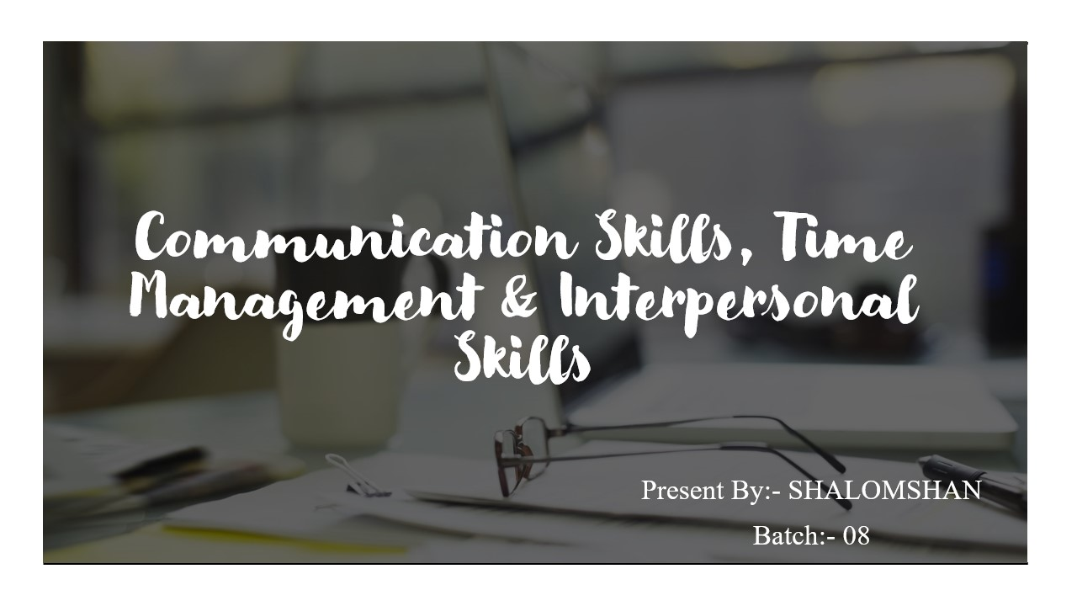

Figure 3 Introduction Slide

Hi everyone my name is shalomshan. I am studying at bcas campus csd batch 08. So today I will conduct this presentation communication skills, time management & interpersonal skills. So I will jumped to next slides

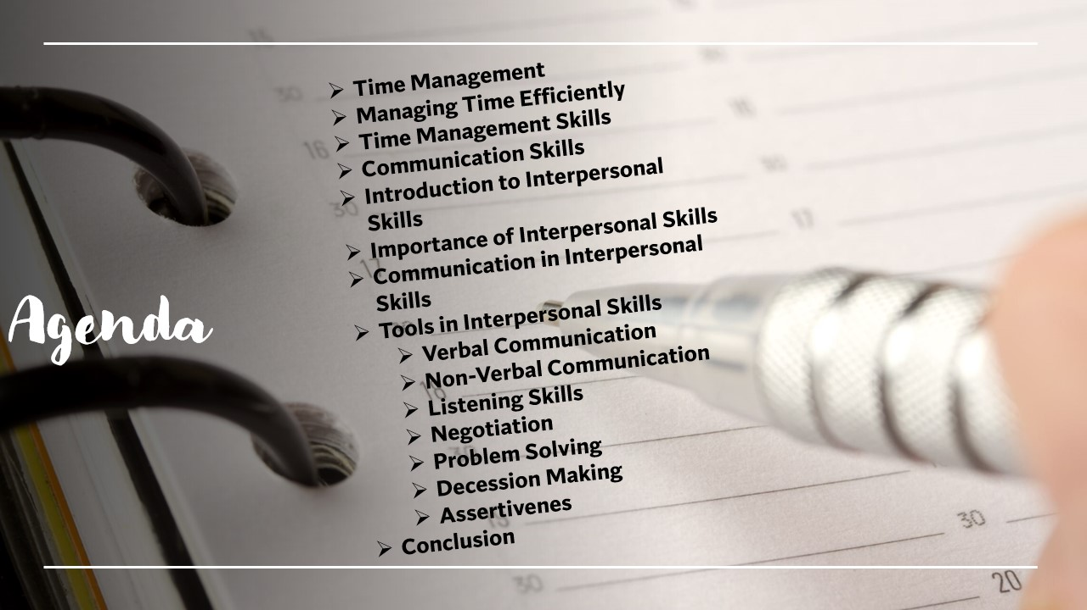

Figure 4 Agenda

This is my content page it is my table of content these topics are covered today.

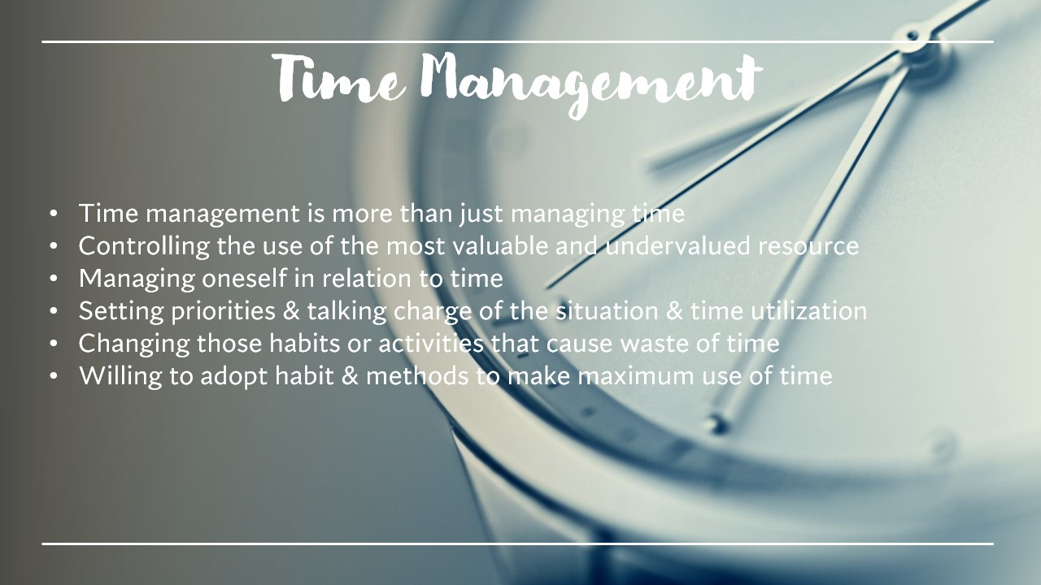

Figure 5 Time management

Time management. Time management is more then just managing time. Controlling the use of the most valuable and undervalued resource. Managing oneself in relation to time. Setting priorities and taking charge of the situation and time utilization. Changing those habits or activities that cause waste of time. Willing to adopt habits and methods to make maximum use of time.

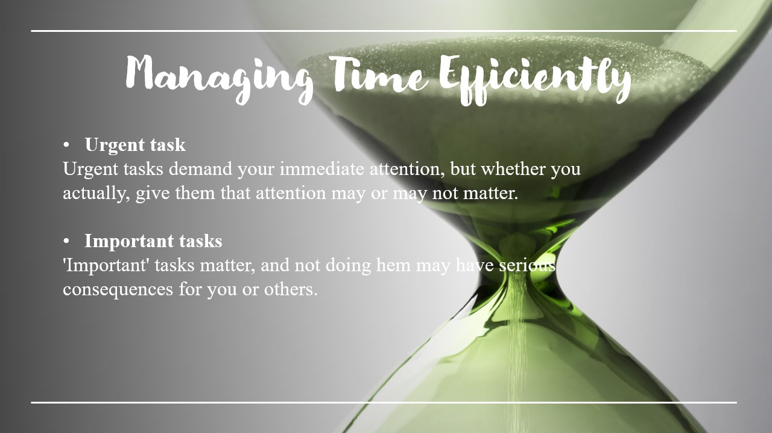

Figure 6 Managing time efficiently

Managing time efficiently. Urgent tasks urgent task demand your immediate attention, but whether you actually give them that attention may or may not matter.

Important tasks important task matter, and not doing them may have serious consequences for you or others.

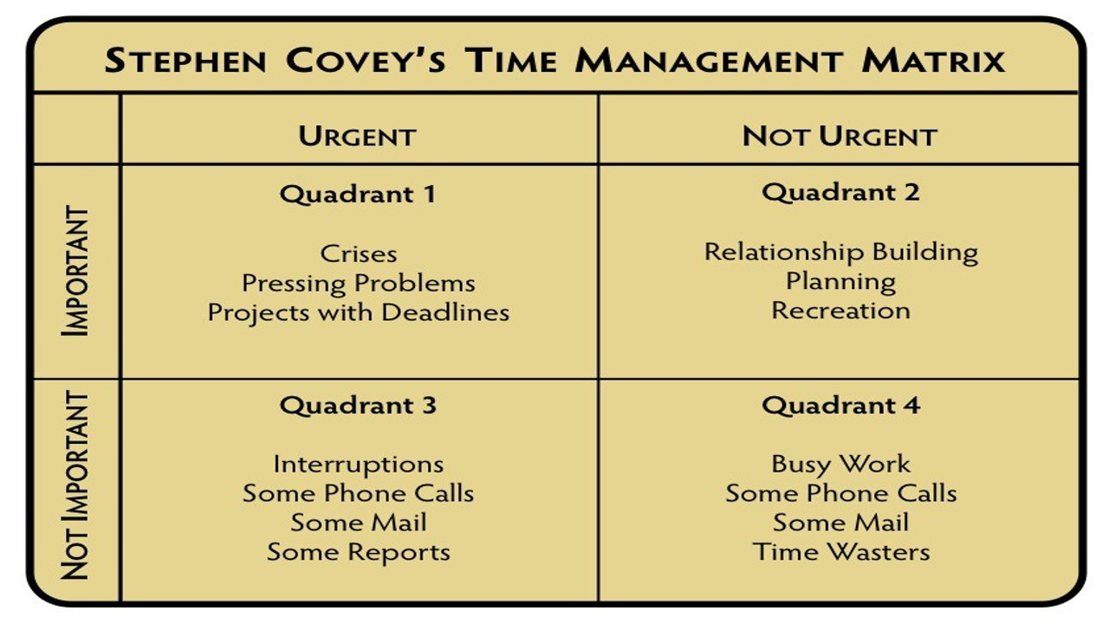

Figure 7 Managing time efficiently

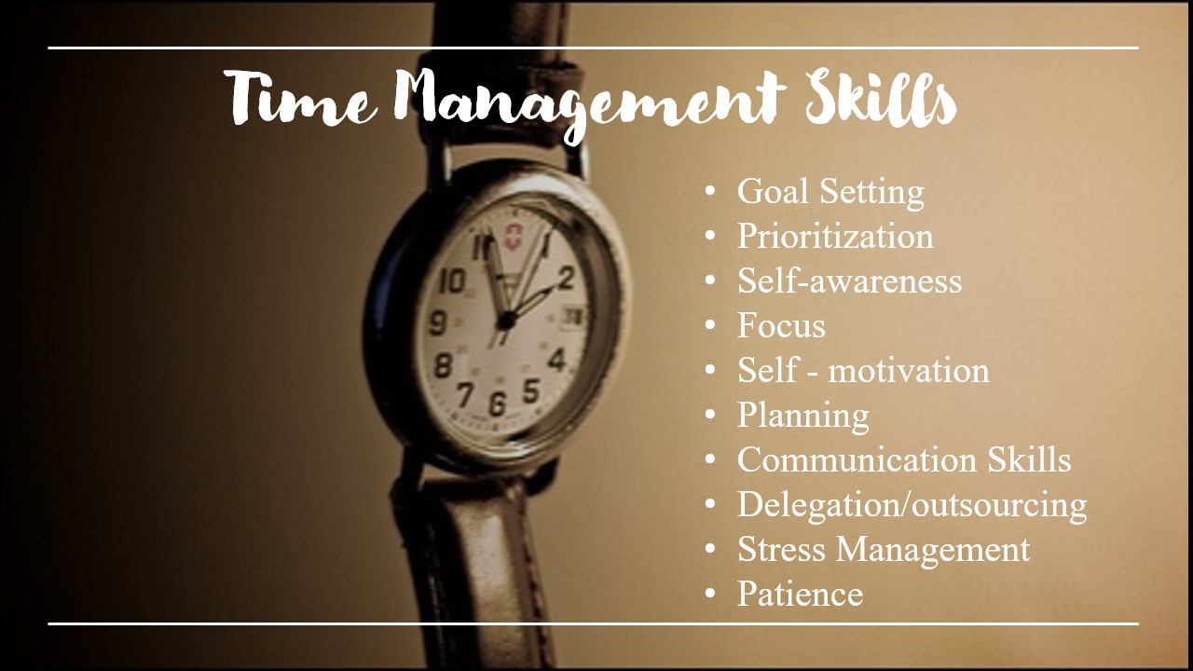

Figure 8 Time management skills

Time management skills are goal setting, prioritization, self-awareness, focus, self-motivation, planning, communication skill, delegation / outsourcing, stress management, patience

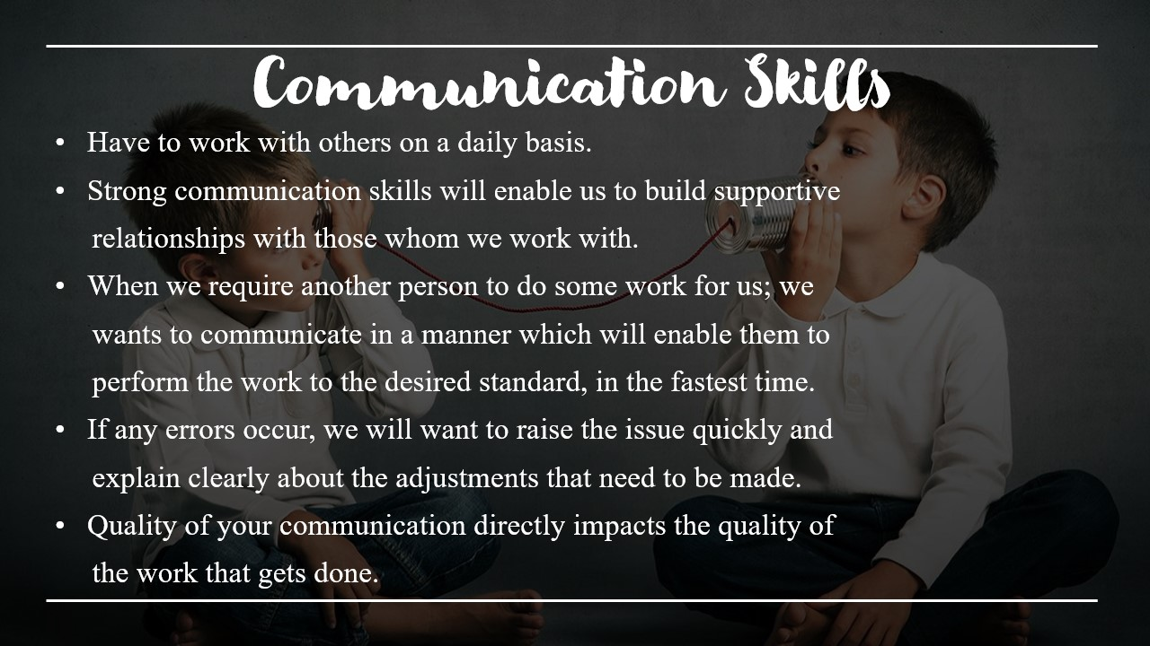

Figure 9 Communication skills

Communication Skills • Have to work with others on a daily basis. • Strong communication skills will enable us to build supportive relationships with those whom we work with. • When we require another person to do some work for us; we wants to communicate in a manner which will enable them to perform the work to the desired standard, in the fastest time. • If any errors occur, we will want to raise the issue quickly and explain clearly about the adjustments that need to be made. • Quality of your communication directly impacts the quality of the work that gets done.

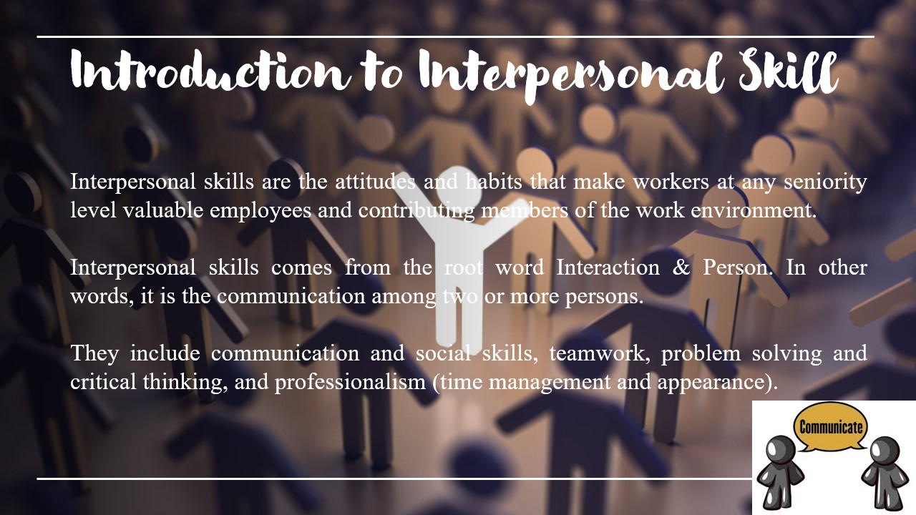

Figure 10 Introduction to interpersonal skill

Course Content ¬ Interpersonal Skills ♣ Introduction (Interaction & Person) ♣ Importance of Interpersonal Skills ♣ Communication in Interpersonal Skills¬ Tools in Interpersonal Skills ♣ Verbal communication ♣ Non-verbal communication ♣ Listening skills ♣ Negotiation ¬ Emotional Quotient (EQ) with Interpersonal Skills ♣ Integrating EQ to Interpersonal Skills to perform better at your workplace. ♣ How can you develop your EQ skills to perform better at your workplace position? ♣Problem-solving ♣ Decision-making ♣ Assertiveness ¬ Strategic Leadership ♣ Applying EQ to Address Your Workplace Challenges

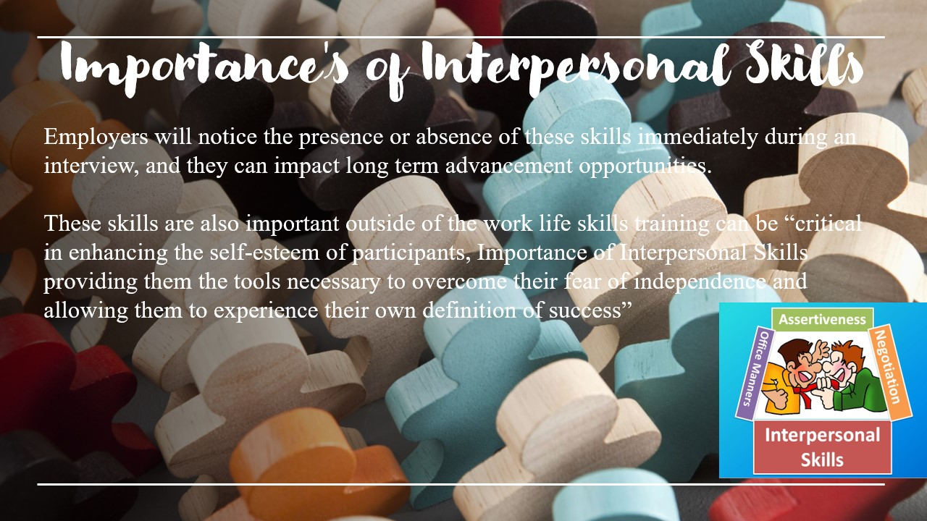

Figure 11 Importance’s of interpersonal skills

Employers will notice the presence or absence of these skills immediately during an interview, and they can impact long- term advancement opportunities. These skills are also important outside of the work environment: life skills training can be “critical in enhancing the self-esteem of participants, Importance of Interpersonal Skills providing them the tools necessary to overcome their fear of independence and allowing them to experience their own definition of success”

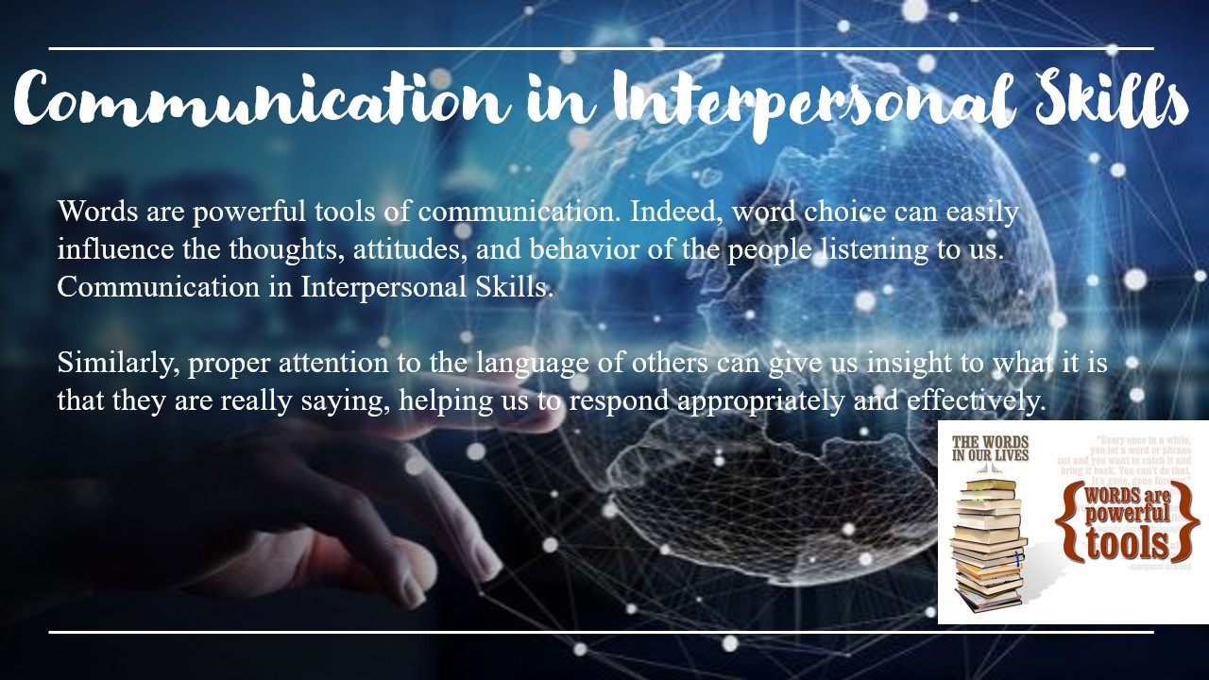

Figure 12 Communication in interpersonal skill

Words are powerful tools of communication. Indeed, word choice can easily influence the thoughts, attitudes, and behavior of the people listening to us. Communication in Interpersonal Skills Similarly, proper attention to the language of others can give us insight to what it is that they are really saying, helping us to respond appropriately and effectively.

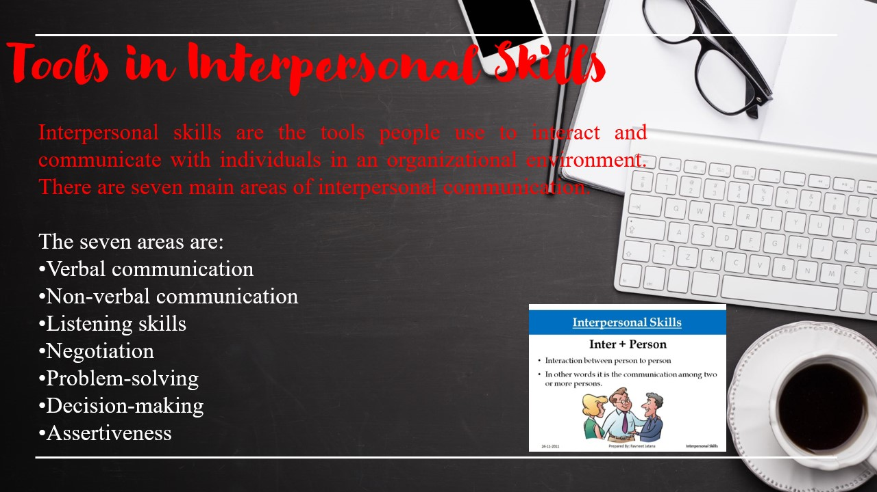

Figure 13 Tools in interpersonal skills

Tools in Interpersonal Skills The seven areas are: •Verbal communication •Non-verbal communication •Listening skills •Negotiation •Problem-solving •Decision-making •Assertiveness Interpersonal skills are the tools people use to interact and communicate with individuals in an organizational environment. There are seven main areas of interpersonal communication.

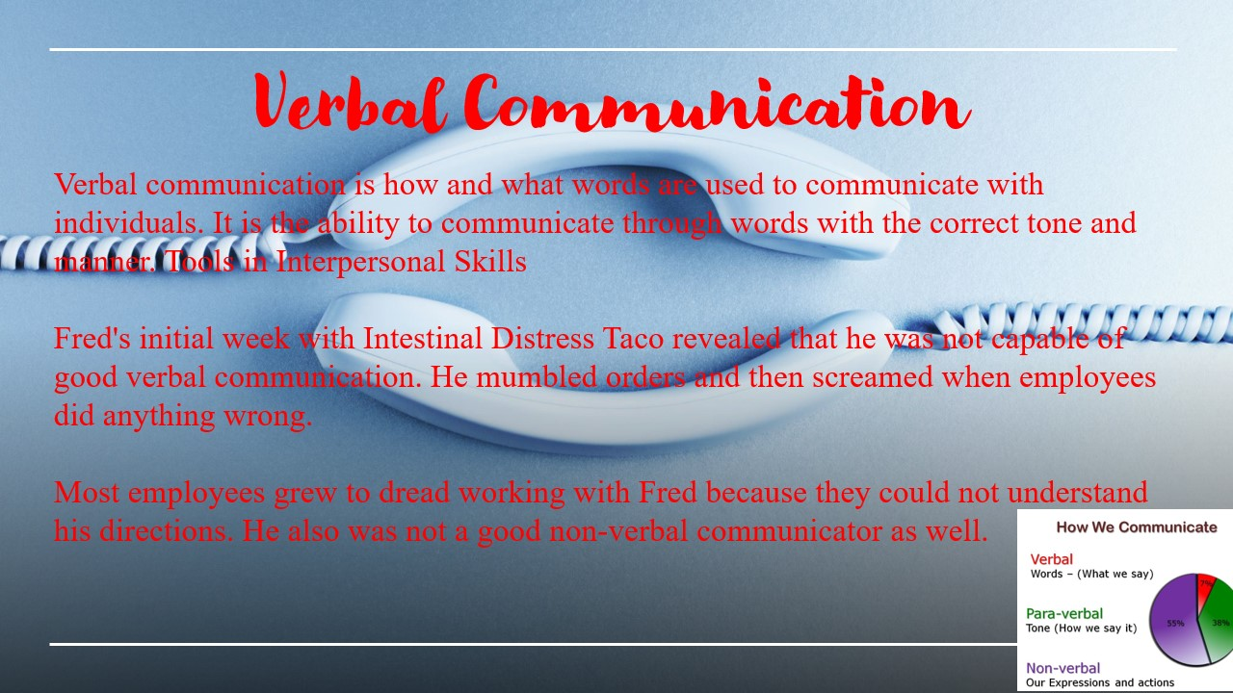

Figure 14 Verbal communication

Verbal Communication Verbal communication is how and what words are used to communicate with individuals. It is the ability to communicate through words with the correct tone and manner. Tools in Interpersonal Skills Fred's initial week with Intestinal Distress Taco revealed that he was not capable of good verbal communication. He mumbled orders and then screamed when employees did anything wrong. Most employees grew to dread working with Fred because they could not understand his directions. He also was not a good non-verbal communicator as well.

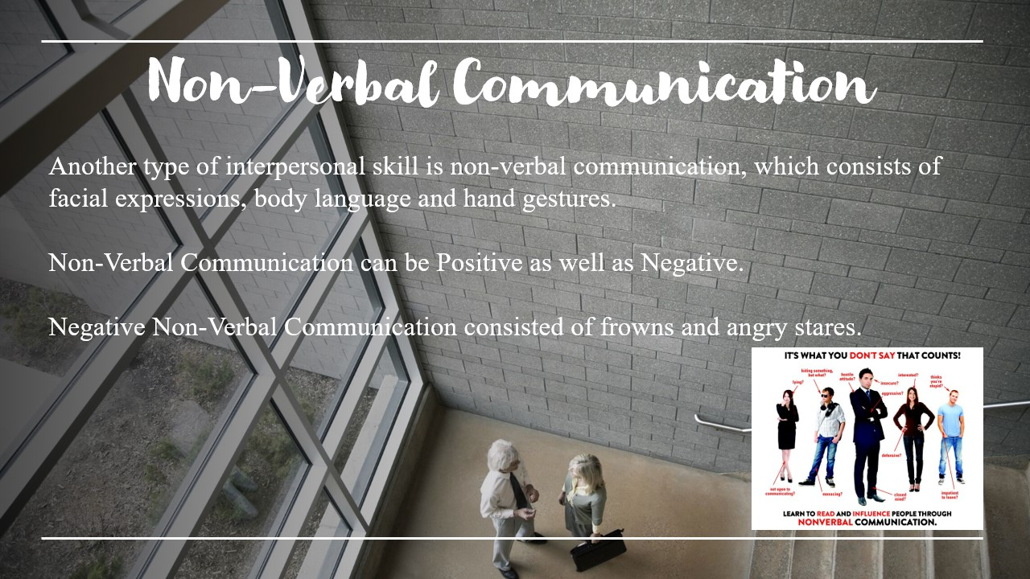

Figure 15 Non-verbal communication

Another type of interpersonal skill is non-verbal communication, which consists of facial expressions, body language and hand gestures. Negative Non-Verbal Communication consisted of frowns and angry stares.

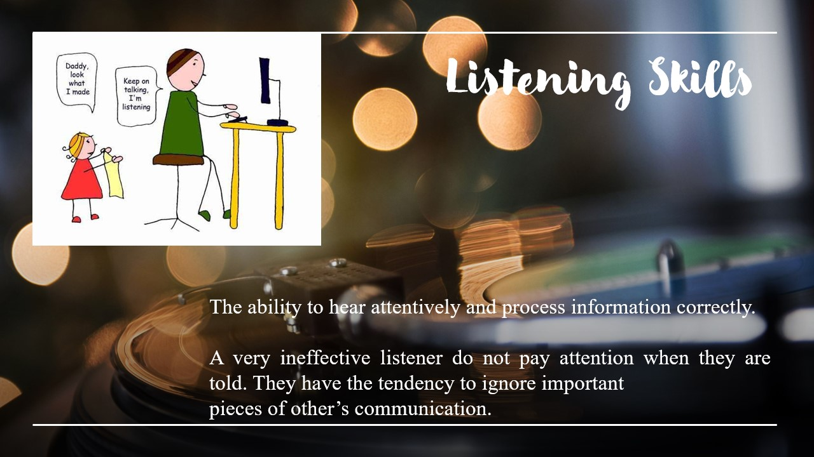

Figure 16 Listening Skills

Listening skills The ability to hear attentively and process information correctly. A very ineffective listener

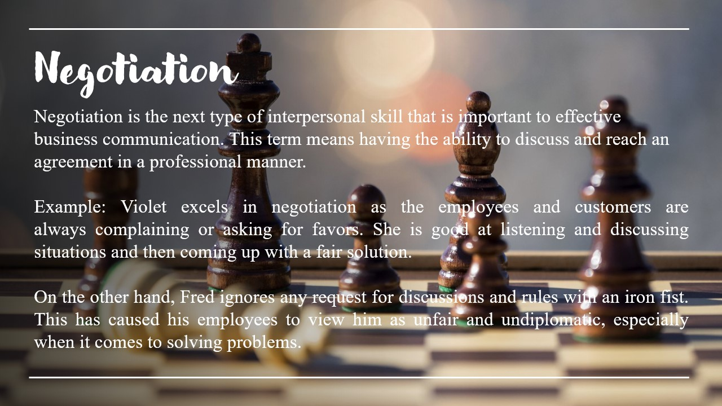

Figure 17 Negotiation

Negotiation Negotiation is the next type of interpersonal skill that is important to effective business communication. This term means having the ability to discuss and reach an agreement in a professional manner. On the other hand, Fred ignores any request for discussions and rules with an iron fist. This has caused his employees to view him as unfair and undiplomatic, especially when it comes to solving problems.

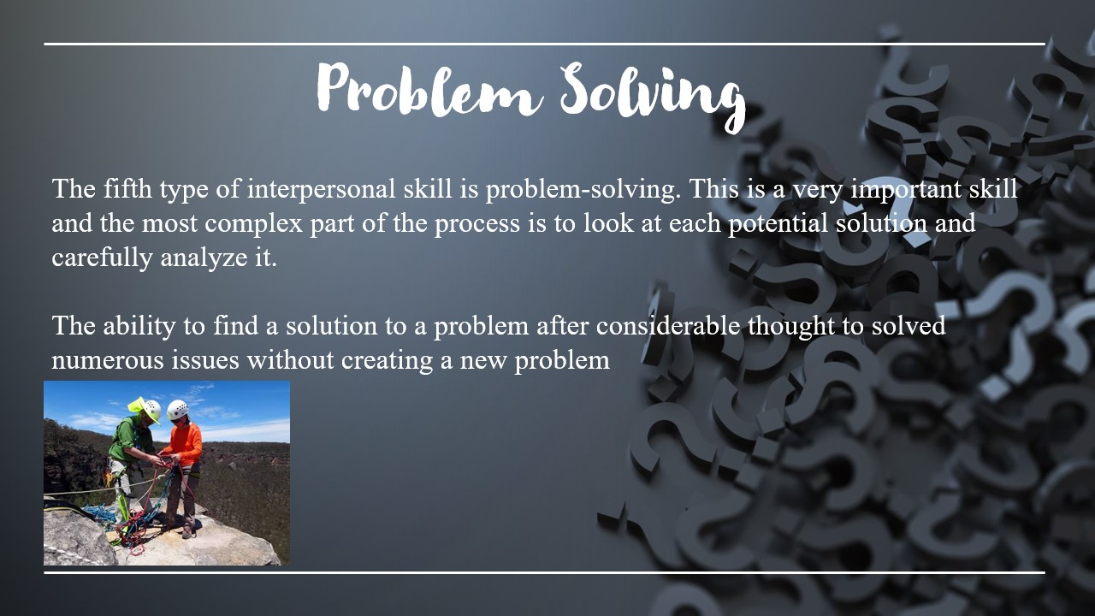

Figure 18 Problem solving

Problem-Solving The fifth type of interpersonal skill is problem-solving. This is a very important skill and the most complex part of the process is to look at each potential solution and carefully analyze it.

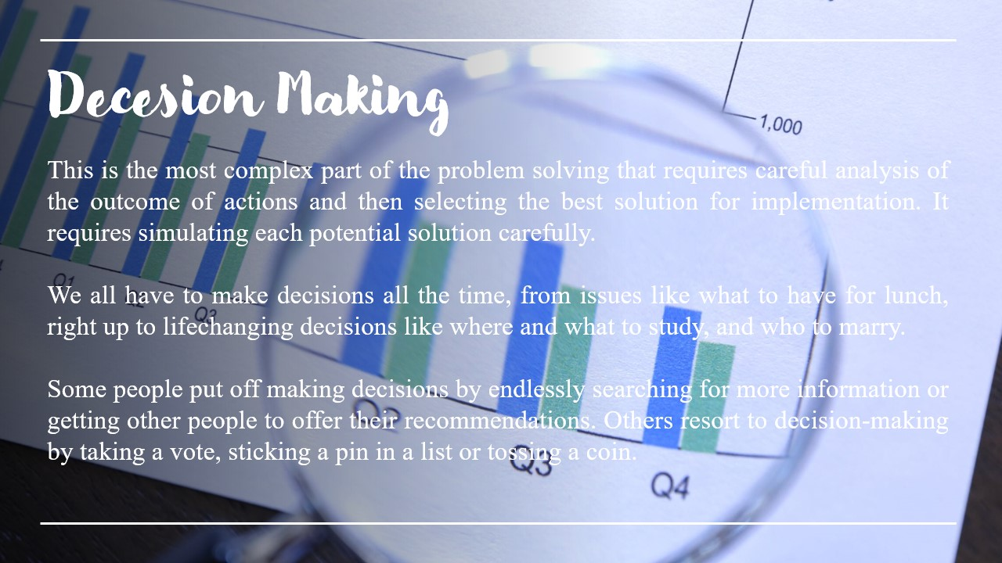

Figure 19 Decision making

Tools in Interpersonal Skills We all have to make decisions all the time, from issues like what to have for lunch, right up to life- changing decisions like where and what to study, and who to marry. 6.Decision Making This is the most complex part of the problem solving that requires careful analysis of the outcome of actions and then selecting the best solution for implementation. It requires simulating each potential solution carefully. Some people put off making decisions by endlessly searching for more information or getting other people to offer their recommendations. Others resort to decision-making by taking a vote, sticking a pin in a list or tossing a coin.

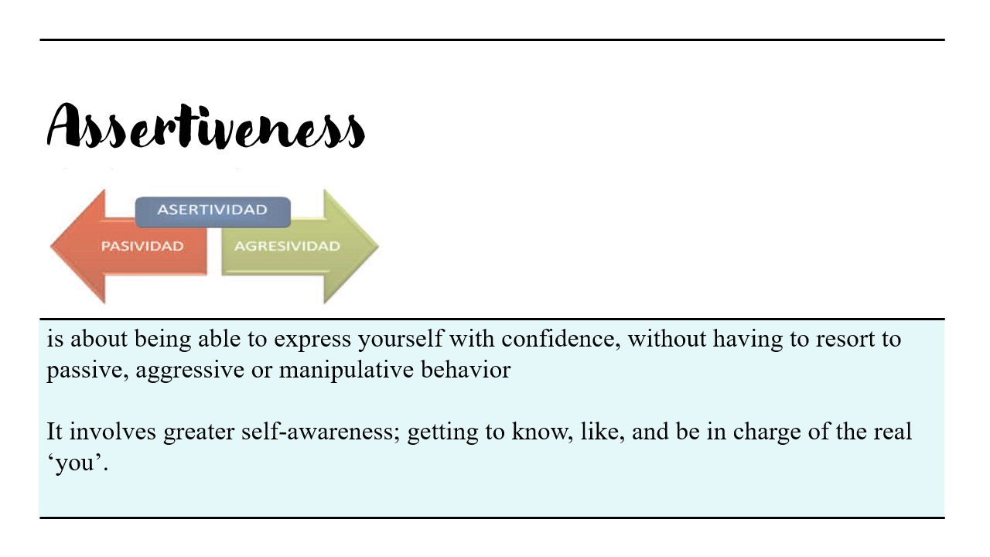

Figure 20 Assertiveness

Tools in Interpersonal Skills It involves greater self-awareness; getting to know, like, and be in charge of the real ‘you’. 7. Assertiveness is about being able to express yourself with confidence, without having to resort to passive, aggressive or manipulative behavior



Figure 21 Conclusion



Figure 22 Thank you

# Applying critical reasoning and thinking to a range of problem - solving scenarios.

## Problem solving skills

Groups tend to make for one of two reasons: either for strictly social functions (a celebration, for example) or to induce one thing accomplished. In the latter case, there will be some variety of drawback finding needed of the cluster. It is once a gaggle is attempting to accomplish one thing that the interactions or dynamics become stronger, particularly if the cluster is beneath constraints in time and resources. There are structured experiences, equivalent to “**Broken Squares**”. Often a reasonably easy, straightforward exercise that may bring out variable designs and skills may build a gaggle cohesive and effective. It will facilitate cluster members learn what helps and what hinders cluster drawback finding.

Successful group problem solving depends first on good communication among the members. By “communication”, the author means the sharing of information by everyone. Silence does not mean approval. Group members do know that each person has a contribution to make. Members must offer what they know, what they observe, what they think, what they feel the group to be most effective.

The following are some recommendations for effectively solving a problem as a group and methods that the author’s group used in the process.

* Each member should understand the total problem or task. Someone, usually the chairperson or task leader, should summarize the task that is to be done.

He or she should seek clarification from the members to assure that everyone understands what the group will be doing.

* Each person should realize how he or she could contribute to the solution. Everyone has talent and skills that they were born with, as well as talents and skills they have acquired.

Most of us tend to downplay or minimize what we have to offer. Problem solving is no time to be modest about one’s talents. All available skills and talents should be on the table for use by the group in solving its problem.

* It is the group’s responsibility to help manage the group’s dynamics; for example, to help the shy person to contribute, and to help the dominant person make time available for others to speak.
* Sometimes members lose sight of what the original purpose was and may get sidetracked. These “detours” can waste a lot of the group’s time. It is important to keep the purpose, goal, or task in mind, and to bring the discussion back to the stated focus. This is the shared responsibility of all group members.

## Tools and Methods use when solving a problem in a group

The author will illustrate two main methods that they have used when they solve problems in the team. They have used these methods effectively, because of those solving problems was easy for some extent. However, the reader should get an estimate about what is problem solving and what are the methods which use when it does.

## Brainstorming

Brainstorming is the name given to a circumstance when a gathering of individuals meets to create new thoughts around a particular territory of intrigue. Utilizing rules, which expel hindrances, individuals, can think even more uninhibitedly and move into new regions of thought thus make various new thoughts and arrangements. The members yell out thoughts as they strike them and afterward expand on the thoughts raised by others. Every one of the thoughts is noted down and are not censured. Just when the brainstorming session is over are the thoughts assessed.

Refer the below diagram for the one of the sample brainstorming which the team did before the training event.

Six Sides

Brainstorming

7/2018

/

3

Choosing a topic for the training event.

Group members threw different ideas on the

table.

The leader chose two topics from those

ideas and got the feedback for that topics

from other members.

Some group members agreed to the two

topics and some didn't. So, the group further

analyzed the two topics.

Finally, all the members agreed on single

topic and proceeded with it.

After all the procedures members made

arguments for and against the topic.

Figure 3 Six Sides Brainstorming for a problem

The above brainstorming took place for choosing a relevant topic for the group to conduct the training event. The above six steps were the most embedded from all the others. It shows how

to categorize the problem to different aspects and solve them easily. The group did many brainstorming activities and the above chat is one from them.

## The Drill - Down Technique

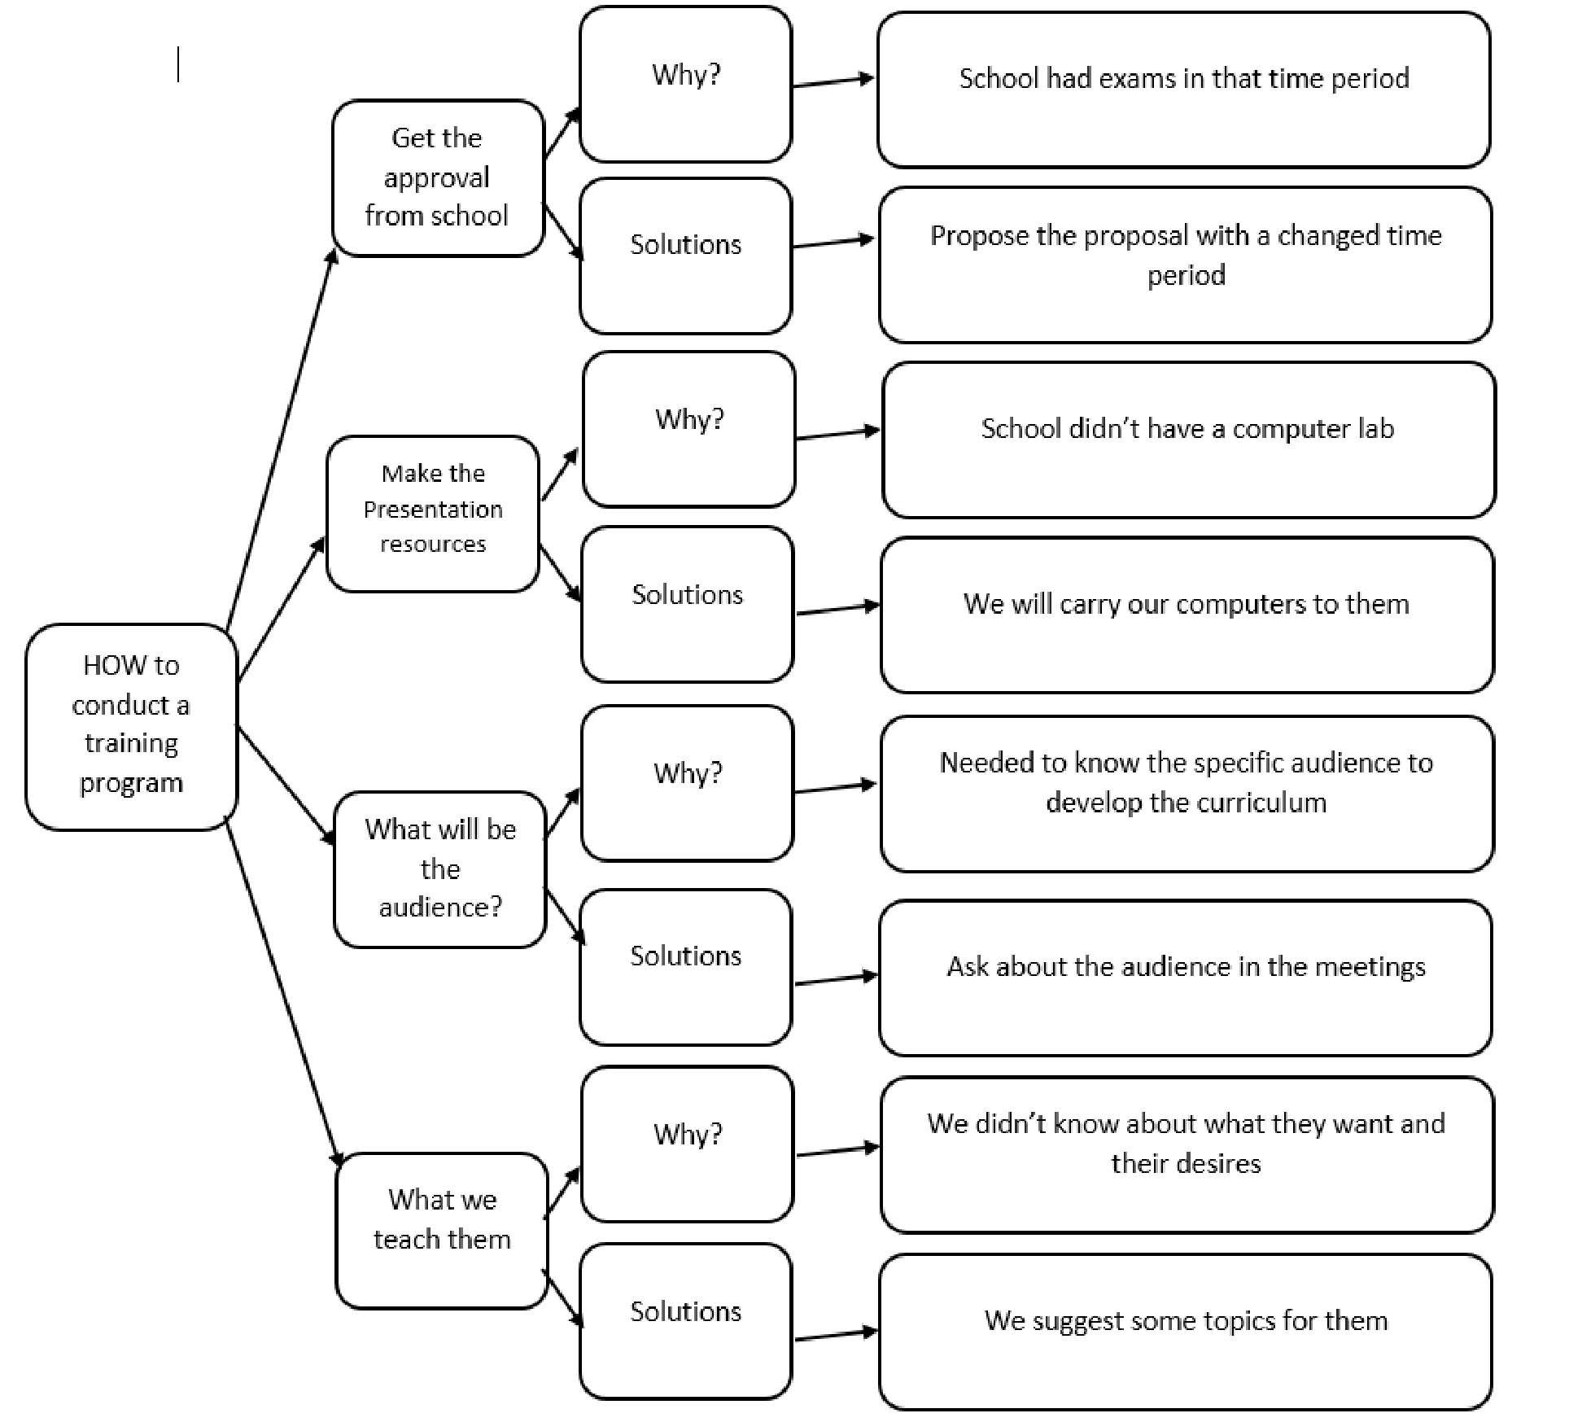Drill Down is a simple technique for breaking complex problems down into progressively smaller parts. To use the technique, start by writing the problem down on the left – hand side of large sheet of paper. Next, write down the points that make up the next level of detail on the problem a little to the right of this. These may be factors contributing to the problem, information relating to it, or question raised by it. This process of breaking the problem down into its components part is called ‘Drill Down’.

Problem-solving skills are necessary in all areas of life, and team problem solving activities can be a great way to get members prepped and ready to solve real problems in real life scenarios. Whether in school, work or in their social relationships, the ability to critically analyze a problem, map out all its elements and then prepare a workable solution is one of the most valuable skills one can acquire in life.

The author has mentioned the above two methods which his team used when solving a problem while delivering the training program. Broken Squares tool will be added in the annexures under “Problem – solving Skills”. It was also an important method that the author’s team used frequently. The using of the tool and examples will be in the annexures for reader’s further researches and studies.

# Applying Critical Reasoning

## Critical Path Analysis

The reader might be confused by Critical Path Analysis (The author has used the short form CPA from now on words for ease if the narration), what is CPA? Let the author restate it in a way that is easier to understand.

The critical path is simply all the tasks that determine the end date in a project schedule. In this context, it is referred as professional schedule. If one of those tasks is late by one day, then the project end date will be extended by one day. Oftentimes, there will be tasks that are not on the critical path; this is due to the slack in the project schedule. If the reader refers to the current schedule, you can examine the chart and quickly identify the tasks that have some float compared to the tasks that have no slack.

**Slack:** Slack is the amount of time a task can be delayed without affecting the start date of a subsequent task. The critical path methodology is simply a technique to identify all the tasks that will directly affect the project end date.

**Creating a Critical Path (The author’s team):**

There are couple of steps to proceed to design a critical path. The author has mentioned all the steps which his team when creating a critical path.

* Identify all steps in the event process or work plan.
* Document the steps in the sequence in which they occur.
* Identify the relationships between steps, and document the dependencies between them.
* Determine the latest allowable start and end time or date when each step can occur without delaying the next step and, subsequently, the whole value stream or work plan.
* Calculate a float value for each task. Critical tasks usually have zero float. Noncritical tasks will have a numeric value associated with them, representing slack time.
* Calculate the float for each step by subtracting the Early Start time or date from the Late Start time or date and assign a float value to each task and sub-task.
* Using the information collected above, identify the critical and non-critical tasks and sub-tasks by determining the duration of the value stream or work plan.
* Chart/document the critical path.

Refer the below figure to get an idea about the functions of CPA;

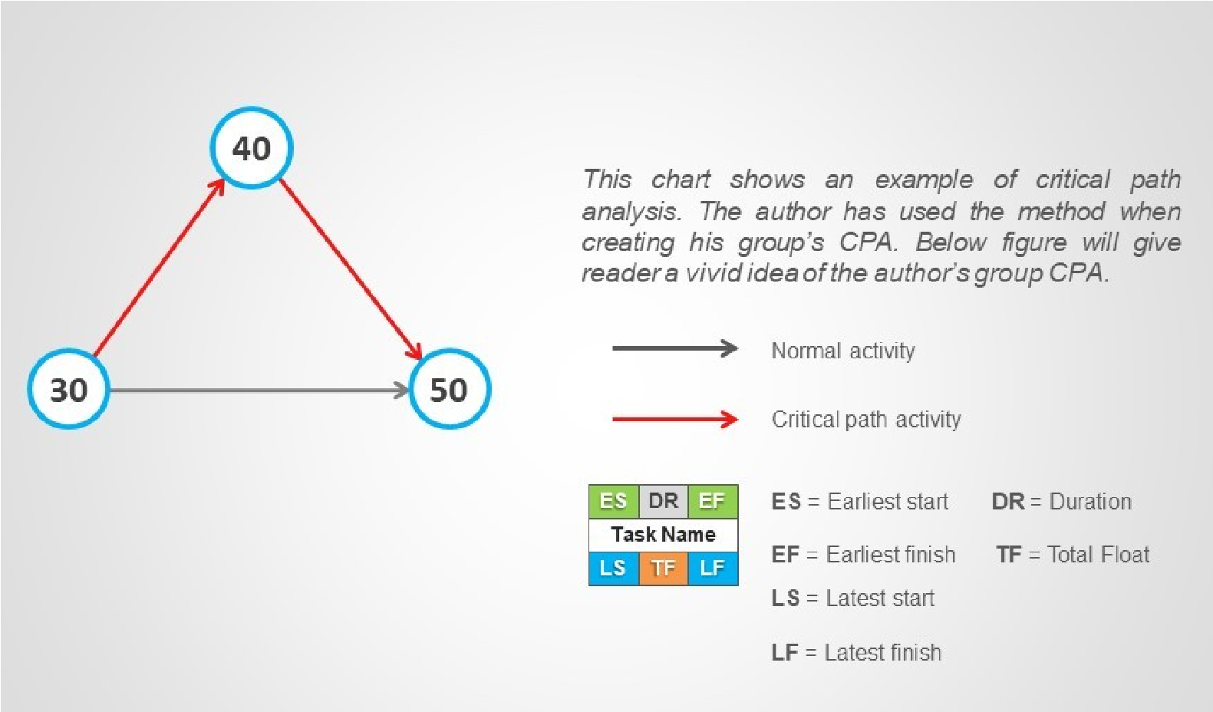

Figure 4 Main Functions in CPA

## Critical Path Analysis Diagram of the author’s group

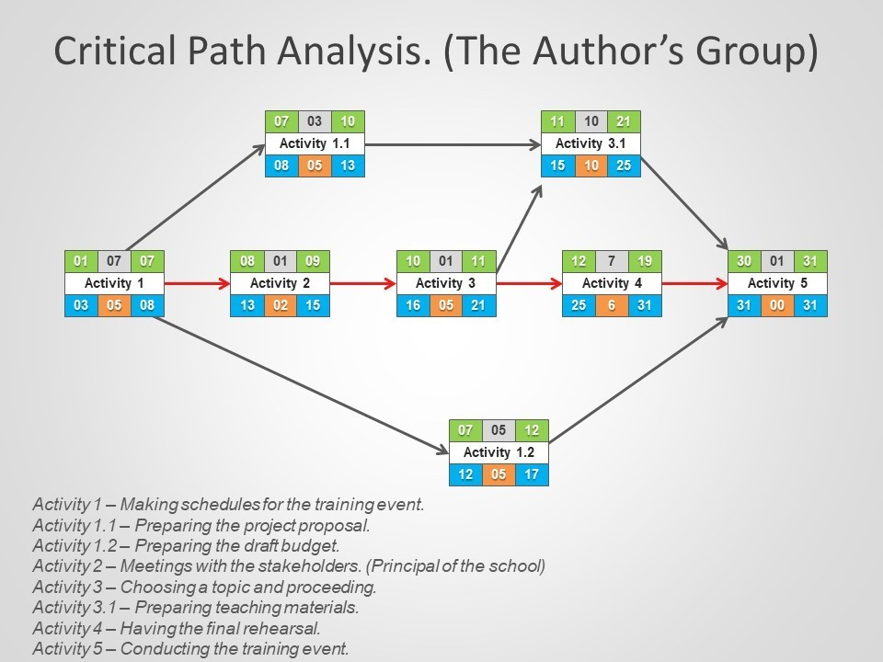

Figure 5 Critical Path Analysis in the author's group

## Justification of the CPA tool

The above diagram was the author’s group CPA diagram, Leader and the author managed to design this diagram according to the professional schedule. Once the decision and planning is made, it was the time to act. In the final step, the group have put the plan into action. As the reader can see in the above figure, the planning has been started from forming a group. Then the group’s main concern was to find a school and then continue from onwards.

The CPA was a new tool to all the group members, as they never knew about something like this. However, there were a lot of float time in the process because the members were unaware of the fact of what to do and how to do it effectively.

**Float Time:**

In the real scenario, when forming the teams and taking actions there were a lot of float time. Group members were not familiar with the tool and that cost the team abit too much when proceeding forward. As an example, when creating a draft budget it took a lot of time because of the collection of money. Even though the proposal had a draft budget, it was not the best budget. Even though it has a lot of float time it did not affect the training event that much, unlikely the below incident which cost the team in a bad way.

The author’s role was the curriculum developer where he had to prepare the training materials.

He had another two group members to work with. Unfortunately, the author was the only member who prepared the training materials as the other two members were did not communicate with the author well. As the author was a Plant he did the work by his own.

That took some time to complete the work, as he had to do 3 times the work as he had. In other case it increased the float time of the operation, because of that the trainers got their working materials a bit late. After that, trainers complained that they do not have enough time to practice the presentation.

As the author was a good communicator as well as a socialize person he managed to work with the trainers and complete the task in the given time. In the given context, trainers practicing the presentations is a **dependent** on preparing the working material.

As the reader has seen above, a small miscalculation can lead a team to a vast devastation, because of the author’s socialize and communication skills he did manage to come up with a solution and it shows how effective and how efficient he was while working in a group.

As for now, the author has talked about how effective CPA was to his group when delivering the training program. Let us take a small turn and analyze how other people have used this method when they work in a company or in a working area. Example and context is below.

The reader can get a vivid idea about CPA and how it works when comparing the author’s scenario and below example. Obviously, after the full workout the reader can apply these methods in his or her working area.

## Different Illustrations of Critical Path Analysis

In order to use CPA let’s first consider a scenario. The below scenario is making a small building. Let’s consider this scenario and try to understand how to use CPA.

Activity

Duration (In days)

A - Prepare foundation.

7

B - Make and position doorframes.

2

C - Lay drains, floor base and screed.

15

D - Install services and fittings.

8

E - Erect walls.

10

F - Plaster celling.

2

G - Erect roof.

5

H - Install door and windows.

8

I - Fit gutters and pipes.

2

J - Paint outside.

3

Table 2 Different of CPA illustrations

Clearly some of these activities cannot be started until other activities have been completed for example

Activity G cannot begin until Activity E has been completed. The following table shows which activities must precede which,

1. must follow E,
2. must follow A and B,
3. must follow D and G,
4. must follow E,
5. must follow G,
6. must follow C and F,
7. must I

These incidents are call **Precedence Relations.**

The network shown below can represent all this information.

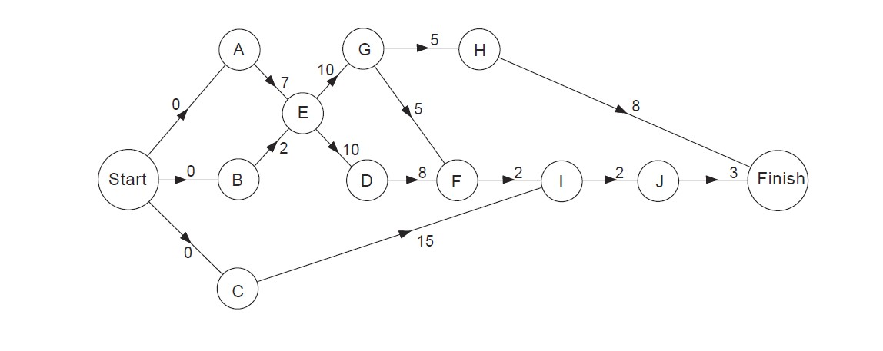

Figure 6 An example for CPA in a different working area

In this network, a vertex represents each activity. Joining vertex X to vertex Y shows that activity X must be completed before Y can be started. The number marked on each arc shows the duration of the activity from which arc starts. Note the use arc here to mean direct edge. Sometimes you can easily form the network activity.

However, the whole point of illustrate another example apart from the group’s CPA, to reader to understand the value of this method and tool when solving a problem.

The activities, which took place when designing the CPA and their evidences, have been added to the annexures under “Critical Path Analysis”.

# Process of applying critical reasoning

Pros and Cons of Critical Path Analyzing

|  |  |
| --- | --- |
| ADVANTAGES | DISADVANTAGES |
| Helps reduce the risk and costs of complex projects. | Reliability of CPA largely based on accurate estimates and assumptions made. |
| Encourages careful assessment of the requirements of each activity in a project | CPA dose not guarantee the success of a project that still needs to be managed properly. |
| Provides members with a useful overview of a complex budgeting | Too many activities may the network diagram too complicated. Activities might themselves have to be broken down into mini projects. |
| Links well with other aspects of planning include budgeting. | CPA operates on the assumption that there is a precise known time that each activity in the project will take. However, it my not be true in real practice. |
| A decision-making tool and a planning tool all in one | Resource may not actually be as flexible as management hope when they come to address the network float |
| It identifies the most critical elements in the project. Thus, the management is kept alert and prepared to pay due attention to the critical activities of the project. | CPA time estimate are not based on statistical analysis |

Table 3 Pros & Cons of CPA

**Evaluation:**

Once the decision and plan are made, it is time to act. Evaluation is often a neglected step in the decision-making process. The key to evaluation is to seek feedback constantly on how your plan is doing. Get feedback from subordinates. Go to the point of the action and determine first hand if the plan is working or not. If not, determine why not and take immediate action to correct the plan. If your problem is still not solved, go back to the list of options and choose another. Follow the same steps.

## Things, which can be improved in the author’s team;

According to the evaluation of the CPA, the author’s team can also gain some knowledge about how to work on more effectively in a given context. In this scenario, as the author has explained there were a lot of float time and miss directional parts. When the evaluation is done the author’s, team should reduce those float tie and miss directions.

As an example, the team spent a lot of time when finding the school. It went on even after the last end date in the CPA. Next time around through some different communication skills, the author’s team can surely reduce that sort of mistakes and it will reduce the float time.

When consider about the float time again the author’s team can reduce it in the upcoming projects as they have a better knowledge of what to do because of the mistakes of this training event. The reader should understand that CPA steps are depending on each different step.

Without continuing one-step then a team cannot be done the other steps.

# Discussion on the importance and dynamics of working within a team and the impact of team work

## Working within a Team

## Teamwork

A team is ‘a group of people with a full set of complementary skills required to complete a task, job, or project’.

The main idea behind the creation of a team is having people working as a group to achieve a goal. Every team/group is different because it can be made up of people coming from diverse backgrounds that have different personalities, values and working styles.

Remember,

**T** – Together

**E** – Everyone

**A** – Accomplishes

**M** – More

**W** – With

**O** – Organization

**R** – Responsibility

**K** – Knowledge

These elements are the ingredients that can either make or break a team – if they are not balanced effectively.

**Goal:**

In the given context the author’s group had a specific goal which is to **successfully complete the training program** and all the group members worked as one to achieve it. Many members knew what they were doing and that was really when marching towards the team goal.

A common and meaningful purpose sets the tone. Specific performance goals are an integral part of the teamwork. The author’s group always kept that one goal in their minds. The combination is essential to the performance. By staying rooted in the team’s commitment, today’s vision becomes tomorrow’s reality.

## Winning team

What makes a great team?

The answer is the individual members of the team. That is because each person plays a significant role within a group. This is better understood through the amount of responsibility they share for a project, activity or task and how much they are willing to get involved.

The quicker the team members realize that the easier it will be for them to work out a plan on how to move forward, settle their differences, come up with the desirable results and complete their mission.

When the author’s team was formed the leader specially had concerns about the below aspects which ultimately made the group a winning group.

**Let each person shine** – As members of the team the success of the team needs to be shared, not focused on a single person. The leader always made the other members of the team feel special and made them feel that they are the reason for the team success, which ultimately led the individual member to their own success.

**Make each person committed** - If every person can do his or her role effectively then the team can be successful. This was a key feature of the author’s group because this aspect only happened only for some extent. Why? Some members neglected their roles in the team and did not committed much to the group, because of that some people had double the work, which was a bit of concern even on the event day.

**Accepting and learning from others** - Some group members might not be good in certain areas. They should learn from other members who are good at those areas and others should accept for who they are. The leader always put this into the minds of the group members.

With the above aspects, the team leader guided the team to a winning team and in the given context; winning can be referred as successfully completing the training event.

End of each scenario the group members identified the different aspects of forming a winning team.

## Importance of teamwork

Teams and teamwork have become a central part of work life. It doesn’t mean everybody doing the same thing or everybody being able to do each other’s jobs. It’s more a means to a synergistic way of working, where the sum is greater than the parts.

Properly managed, teamwork maximizes strengths, bringing out the best in each team member, a key theme on this site. These specific, possibly unique individual strengths are then complimented by the strengths of others, or of the team as a unit.

Why is team work important? Points below will endeavor the idea.

**Creates synergy:** Where the sum is greater than the parts. Creating a synergy supports a more empowered way of working, removing constraints which may prevent someone doing their job properly.

**Accomplishment:** When the group works together, the accomplishments will surpass any results associated with any one individual.

**Teamwork motivates unity in the working area:**

A teamwork domain advances a climate that encourages fellowship and loyalty. These affectionate connections inspire representatives in parallel and adjust them to work harder, collaborate and be steady of each other.

People have assorted abilities, shortcomings, relational abilities, qualities, and propensities. Subsequently, when a teamwork domain is not supported this can posture numerous difficulties towards accomplishing the general goals and destinations. This makes a situation where representatives wind up concentrated without anyone else accomplishments and contending with their kindred associates. At last, this can prompt an unfortunate and wasteful workplace. At the point when teamwork is working, the entire group would be spurred and progressing in the direction of a similar goal in concordance.

**Teamwork offers differing perspectives and feedback:**

Great teamwork structures give any association a decent variety of thought, imagination, points of view, openings, and critical thinking approaches. An appropriate group condition enables people to conceptualize by and large, which thusly builds their prosperity to issue explain and land at arrangements all the more productively and viable.

Compelling groups additionally enable the activity to advance, thus making an aggressive edge to achieve goals and targets. Imparting varying insights and encounters fortifies responsibility and can help settle on successful choices quicker, than when done alone. Team effort increases output by having quick feedback and multiple sets of skills come into play to support the teamwork. Team can do the stages of designing, planning, and implementation much more efficiently when a team is functioning well.

**Teamwork provides improved efficiency and productivity:**

When incorporating teamwork strategies, members become more efficient and productive. This is because it allows the workload to be shared, reducing the pressure on individuals, and ensure tasks are completed within a set time period. It likewise enables goals to be more achievable, upgrades the enhancement of execution enhances work fulfillment and builds work pace.

At last, when a gathering of peoples cooperates, contrasted with one individual working alone, they advance a more efficient work yield and can finish assignments quicker because of numerous personalities interlaced on similar goals and destinations of the business.

**Teamwork provides great learning opportunities:**

Working in a team, it enables to learn from one another’s mistakes. Members able to avoid future errors, gain insight from differing perspectives, and learn new concepts from more experienced colleagues.In addition, individuals can expand their skill sets, discover fresh ideas from newer colleagues and therefore ascertain more effective approaches and solutions towards the tasks. This active engagement generates the future articulation; encouragement and innovative capacity to problem solve and generate ideas more effectively and efficiently.

In the given context, the group has used all the necessary aspects on beginning from forming a team to working as a team. Group members have improved by the beginning of the training event. Even though the members were not so keen and sharp in the beginning of the project, they were when it came to the near date of the training event. The author has inserted some evidences of doing teamwork and some letters and screenshots of chats where the members have talked about the event in annexures under “Working within a team”.

When managed properly, teamwork is a better way to work!

# Problem Solving & Building Strategy Presentation Slides

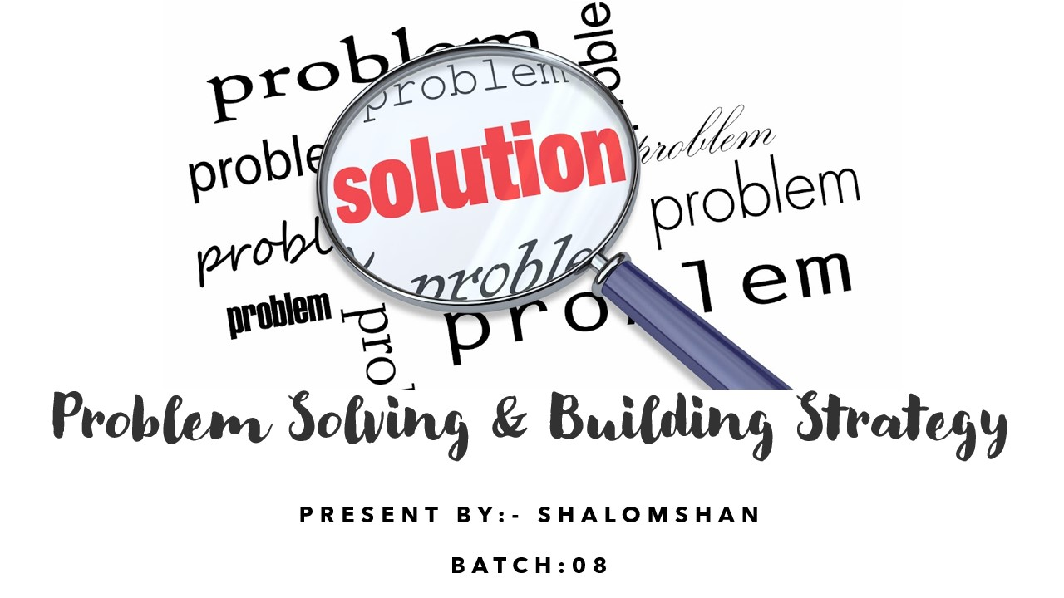

Figure 23 Slide_1

Hi everyone I’m shalomshan. I’m studying BCAS campus CSD batch 8. So today I will conduct this presentation is problem solving & building strategy. So I will jumped to next slide

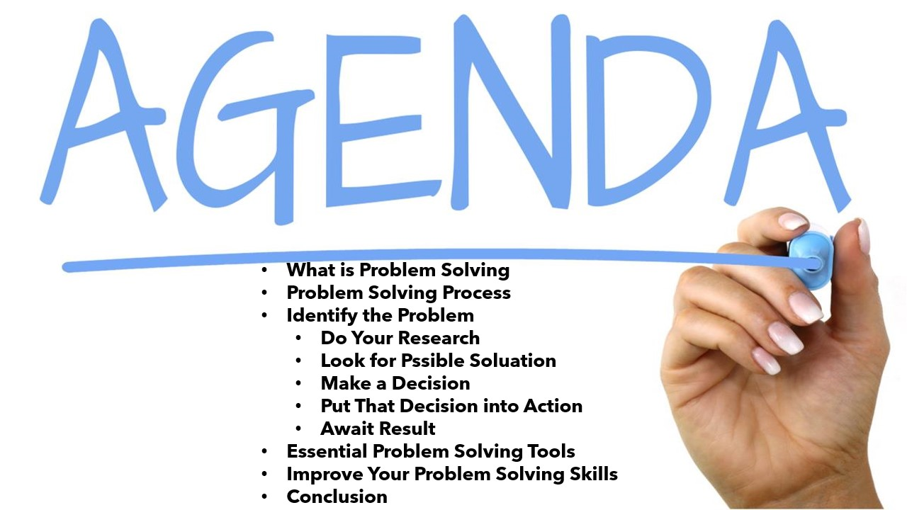

Figure 24 Slide_2

So this is my agenda this is my table of content these are topic I will covered today.

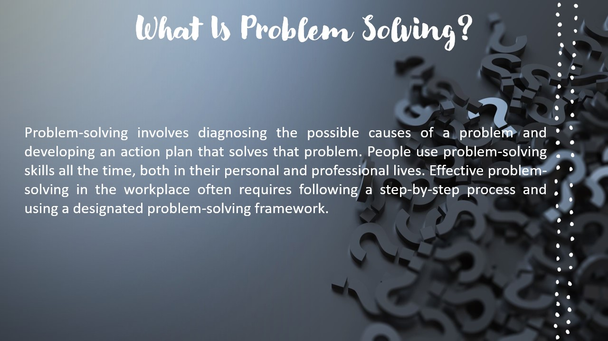

Figure 25 Slide_3

What Is Problem Solving?

Problem-solving involves diagnosing the possible causes of a problem and developing an action plan that solves that problem. People use problem-solving skills all the time, both in their personal and professional lives. Effective problem-solving in the workplace often requires following a step-by-step process and using a designated problem-solving framework.

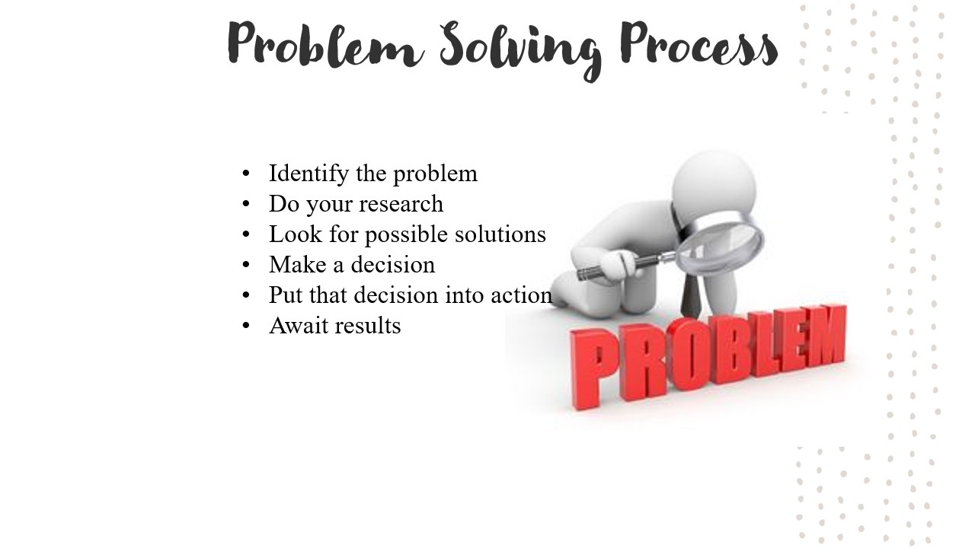

Figure 26 Slide_4

Problem Solving Process

Identify the problem

Do your research

Look for possible solutions

Make a decision

Put that decision into action

Await results

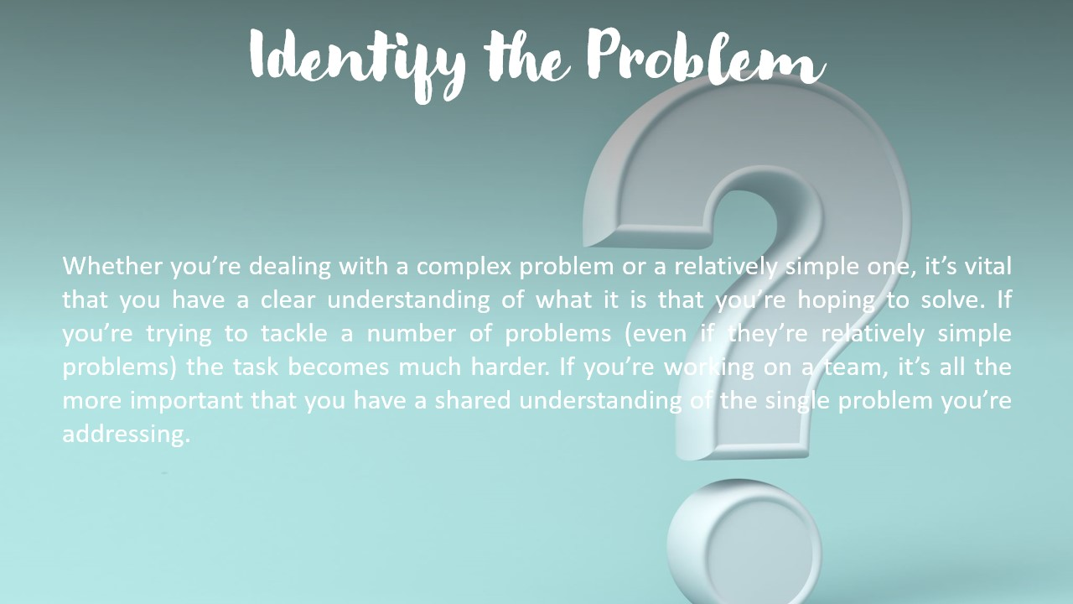

Figure 27 Slide_5

Identify the problem. Whether you’re dealing with a complex problem or a relatively simple one, it’s vital that you have a clear understanding of what it is that you’re hoping to solve. If you’re trying to tackle a number of problems (even if they’re relatively simple problems) the task becomes much harder. If you’re working on a team, it’s all the more important that you have a shared understanding of the single problem you’re addressing.

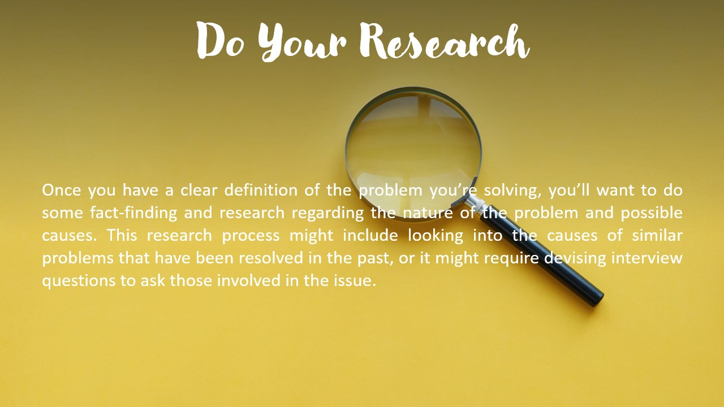

Figure 28 Slide_6

Do your research. Once you have a clear definition of the problem you’re solving, you’ll want to do some fact-finding and research regarding the nature of the problem and possible causes. This research process might include looking into the causes of similar problems that have been resolved in the past, or it might require devising interview questions to ask those involved in the issue.

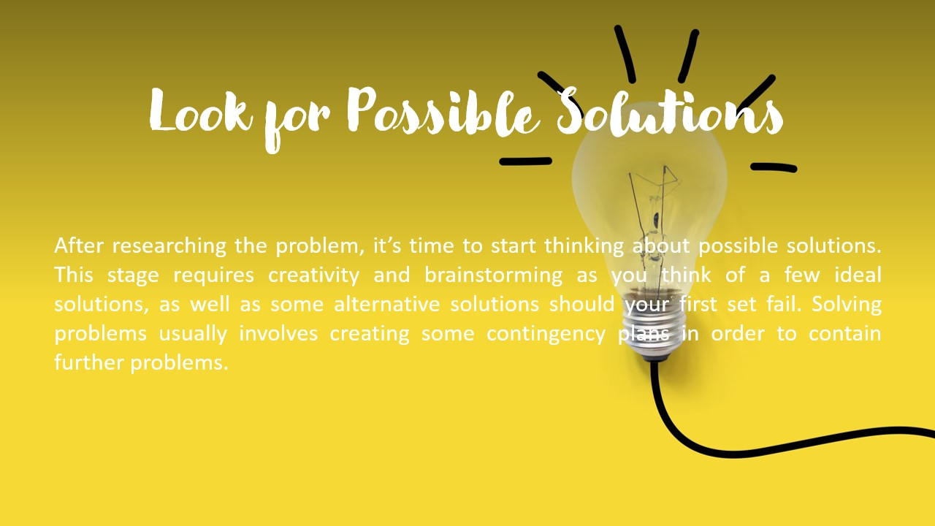

Figure 29 Slide_7

Look for possible solutions. After researching the problem, it’s time to start thinking about possible solutions. This stage requires creativity and brainstorming as you think of a few ideal solutions, as well as some alternative solutions should your first set fail. Solving problems usually involves creating some contingency plans in order to contain further problems.

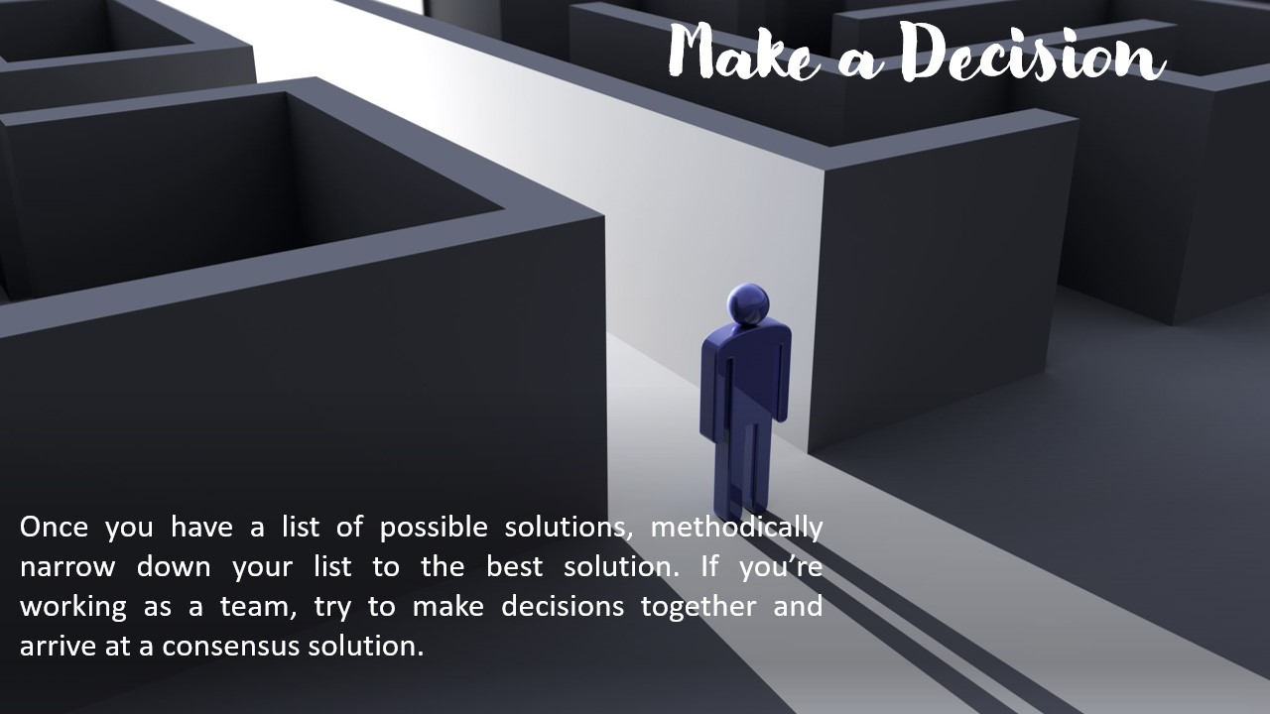

Figure 30 Slide_8

Make a decision. Once you have a list of possible solutions, methodically narrow down your list to the best solution. If you’re working as a team, try to make decisions together and arrive at a consensus solution.

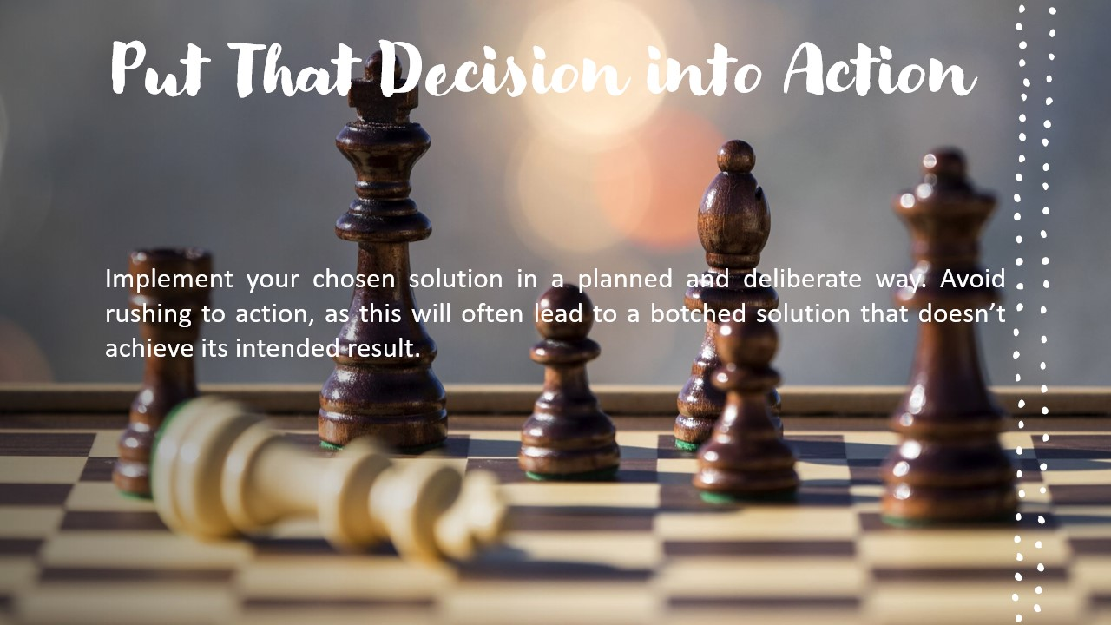

Figure 31 Slide_9

Put that decision into action. Implement your chosen solution in a planned and deliberate way. Avoid rushing to action, as this will often lead to a botched solution that doesn’t achieve its intended result.



Figure 32 Slide_10

Await results. Observe how your solution is working and decide if further action needs to be taken. It’s best to decide on a time frame for observation before you follow up and decide whether or not to make changes to your plan.

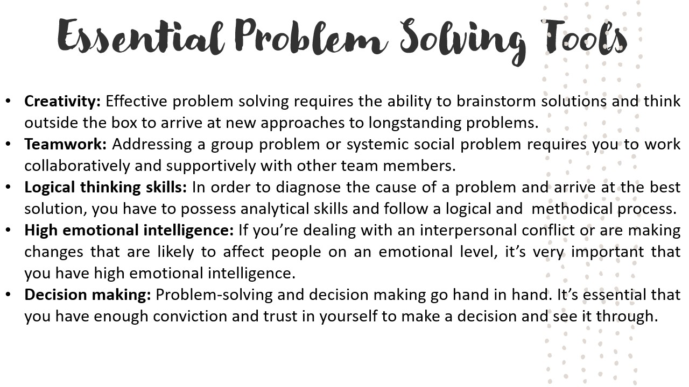

Figure 33 Slide_11

Essential Problem Solving

Tools Creativity: Effective problem solving requires the ability to brainstorm solutions and think outside the box to arrive at new approaches to longstanding problems.

Teamwork: Addressing a group problem or systemic social problem requires you to work collaboratively and supportively with other team members.

Logical thinking skills: In order to diagnose the cause of a problem and arrive at the best solution, you have to possess analytical skills and follow a logical and methodical process.

High emotional intelligence: If you’re dealing with an interpersonal conflict or are making changes that are likely to affect people on an emotional level, it’s very important that you have high emotional intelligence (or EQ).

Decision making: Problem-solving and decision making go hand in hand. It’s essential that you have enough conviction and trust in yourself to make a decision and see it through.

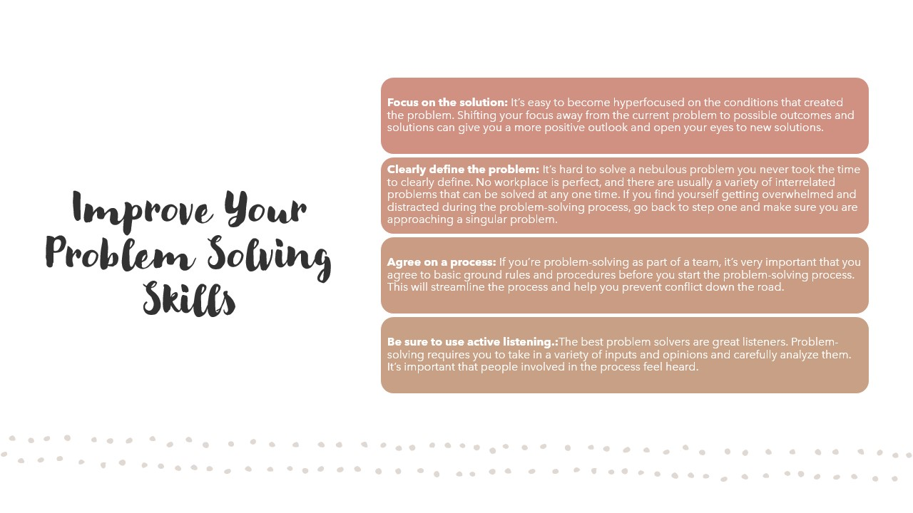

Figure 34 Slide_12

Improve Your Problem-Solving Skills

Focus on the solution. It’s easy to become hyper focused on the conditions that created the problem. Shifting your focus away from the current problem to possible outcomes and solutions can give you a more positive outlook and open your eyes to new solutions.

Clearly define the problem. It’s hard to solve a nebulous problem you never took the time to clearly define. No workplace is perfect, and there are usually a variety of interrelated problems that can be solved at any one time. If you find yourself getting overwhelmed and distracted during the problem-solving process, go back to step one and make sure you are approaching a singular problem.

Agree on a process. If you’re problem-solving as part of a team, it’s very important that you agree to basic ground rules and procedures before you start the problem-solving process. This will streamline the process and help you prevent conflict down the road.

Be sure to use active listening. The best problem solvers are great listeners. Problem-solving requires you to take in a variety of inputs and opinions and carefully analyze them. It’s important that people involved in the process feel heard.



Figure 35 Slide_13



Figure 36 Slide_14

# Analyzing Team Dynamics

## What is the meaning of team dynamics?

The behavioral relationship between members of a group that are assigned connected tasks within a company. Dynamics are affected by roles and responsibilities and have a direct result on productivity. The term “group dynamics” refers to the interactions between people who are talking together in a group setting. Group dynamics can be studied in business settings, in volunteer settings, in classroom settings, and in social settings. Any time there are three or more individuals interacting or talking together, there are group dynamics. In the given context the author has identified two main settings where team dynamics can be formed which are, classroom setting and social setting.

## Team Dynamics Jigsaw

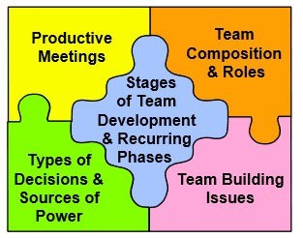

Figure 37 Team Dynamics Jigsaw

The author’s team has used this method to identify the team dynamics more deeply as they wanted to observe the different aspects of building team. Functioning as a successful team requires the integration of many different activities. If any piece of the puzzle is missing, then the groups of people is not likely to functions as a true team.

The figure above illustrates the main issues that will be covered in this material. It is laid out in the form of a jigsaw puzzle to illustrate the learning approach. The author has illustrated below, the real scenario activities while considering the jigsaw puzzle. When considering to the author’s team / group, they had some great team dynamics and that made them a force to be reckoned in the class working area.

## Productive meetings

Albeit singular colleagues perform assignments between group gatherings, a significant part of the collaboration got finished when all colleagues were as one amid gatherings. Indeed, even in the creator's group numerous individuals hated gatherings; nonetheless, profitable gatherings upgraded the possibility of having a fruitful preparing occasion.

Much the same as different processes, gatherings can be considered and always made strides. It is hard to have beneficial gatherings since few individuals know the guidelines and aptitudes required for such gatherings. A similar situation occurred in the creator's group when they composed the principal meeting of the group. In fact, the goal of having constantly improved meetings may be as hard for the team to reach as the improvement goals set for the project. The best way to have productive meetings is to follow the guidelines given below from the start of the project when the members expect to learn new ways of working together.

1. **Use Agendas:**

Each meeting must have an agenda, preferably one drafted at the previous meeting and developed in detail by one or two members prior to the actual meeting. It should be sent to participants in advance, if possible. A meeting is actually a perfect opportunity to achieve a lot of things. It is as chance to catch everybody up on what is going in the overall scheme of things or work.

In the author’s group members exactly knew what they were doing and they had clear cut topics to discuss in the meetings. Secretary made an agenda which is another important factor of conducting a productive meeting because when you have a purpose, you must have a meeting agenda.

In the agenda she listed the work which needs to be done in the available time. The leader was very friendly and strict at the same time and he always encouraged the members to participate in the meetings. If the purpose of your meeting is relevant to those in attendance, leader always wanted them to participate in the discussion and be involved in the decision – making.

Taking minutes and using technology is another main point of productive meetings. The minutes are the record of what was discussed and decided at the meeting and they help to set the agenda for the following meeting.

1. **Have a facilitator:**

Each meeting should have a facilitator who is responsible for keeping the meeting focused and moving. Ordinarily, this role is appropriate for the team facilitator. In the author’s team the role facilitator was assigned to Harshad, who was a person with a bit of aggression and a person who knows all three languages.

Among the facilitator's chief responsibilities were:

* Encourage compliance with the Code of Cooperation and other team norms;
* Keep the discussion focused on the topic and moving along;
* Intervene if the discussion fragments into multiple conversations;
* Tactfully prevent anyone from dominating or being overlooked;
* End discussions.

The facilitator should also notify the group when the time allotted for an agenda item has expired or is about to expire. The team then decides whether to continue discussion at the expense of other agenda items or postpone further discussion until another meeting.

In the team according to the given context the facilitator did a great job as, the leader formed several meetings in a week because the conducting was easy with the help of facilitator.

* + - **Draft next agenda:**

At the end of the meeting, draft an agenda for the next meeting.

* + - **Evaluate the meeting:**

Always review and evaluate each meeting, even if other agenda items go overtime. The evaluation should include decisions on what will be done to improve the meeting next time and helpful feedback to the team leader. You may want to experiment with mid meeting evaluations. Team members always laid their ideas in front of others when evaluating the meeting.

According to the author, productive meetings are very successful method when improving the team dynamics. All the team meetings, agenda, etc.… will be added in the annexures under “Analyzing team dynamics”.

## Team composition and roles they played

Choose or building the right team is vital for the success of any task. Successful projects are usually the result of careful planning and the talent and collaboration of a project’s team members. It is essential that the right people be assigned to a team. Each person should be selected based on his or her knowledge and expertise as well as other potential factors.

The leader of the author’s team was always careful when assigning the roles, which each person had to play in the training event. As to his knowledge, he selected the relative people based on his or her characteristics and experience on a given context. In addition to selecting the appropriate people, leader used key roles that are essential to the overall team's success.

Key roles include Sponsor, Leader, Facilitator, Member, Gatekeeper, Recorder, Timekeeper, and Devil’s advocate.

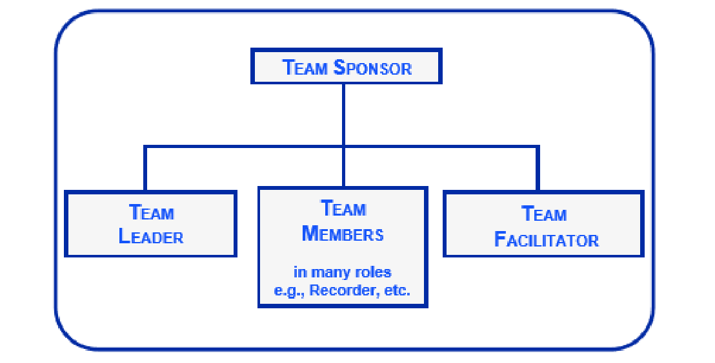

Figure 38 Major Roles in a Team

The above figure illustrates some important aspects of team organizational structure. Note that the Team Leader and Team Facilitator are ‘on the same level’ as all other Team Members. It shows the equality of the members in a sort of manner.

**Sponsor** - The Sponsor oversees and supports the activities of the project teams. Typically, the sponsor is the manager (or instructor) who chose the projects and appointed the teams; however, other people may be involved.

Sponsors do not conduct the actual project; they guide the efforts of the project team. They appoint the project team and together with the team leader determine the project's boundaries.

In the given context the author’s mentor was the team sponsor. He guided the team and always pushed the members to complete the training program.

**Team Leader** - The team leader manages the team: calling and, if necessary, facilitating meetings, handling or assigning administrative details, organizing all team activities, and overseeing preparations for reports and presentations. In the author’s team **Jana** was the leader and he worked accordingly to the face of the scenarios every time possible.

The team leader should be interested in solving the problems that prompted the project, and be reasonably skilled at working with individuals and groups. Ultimately it is the leader's responsibility to create and maintain channels that enable team members to do their work.

According to the author’s perspective the leader was a great person to deal with as he was a perfect example for captain cool as he always kept his cool when solving different problems.

**Facilitator** - The ideal facilitator has a combination of people, technical, and training skills. In the workplace, facilitators should be chosen from outside the process area being studied so that they are neutral to the project. Even though the facilitators should be chosen from outside the project, the team appointed **Harshad** as the facilitator even though he was another regular member of the team.

**Team Member** - Team members are the rest of the people involved in the project. The author was a team member in the team but according to the occasions, he had to be the leader and also had to play different roles. Not everyone who could contribute something worthwhile need be on the team; project team members can always consult with experts or other staff as the project unfolds.

## Belbin’s Team Roles Model

When identifying the team roles there was another model where the team members can fit in.

Belbin identified this model as this model has name after him as **Belbin’s Team Roles Model.** In this model, Belbin identified nine team roles and categorized those roles into three groups.

* Action Oriented Roles
* People Oriented Roles
* Thought Oriented Role

Above roles are assigned to the group members by the leader. He made every member to take part in the ‘Belbin Test’ online and assigned the roles according to the results. These roles were so effective when carrying on the training event.

## Decision Making

## Types of decisions team members made and how effective they were

As a team works at a task, or at team maintenance functions, decisions must be made. The quality of team decision making, and the extent to which a decision is accepted and implemented by team members, is greatly affected by the decision-making process. The six most common team decision-making patterns are given below. The author’s team has made some decisions when organizing the training event those decisions have been categorized below alongside with the six most common decision-making patterns. So that the reader can get a vivid idea about the context which the author’s team faced.

## Unilateral/Authoritarian

One person makes the decision and imposes it upon the team. Often, there is very little input from team members, and acceptance/commitment is low. In the context, the author’s group had a lot unilateral decision. Even though there were a lot of ideas and decisions, they did not affect the outcome that much. As an example, a group member made a decision to change the audience even after getting the approval. It was a unilateral decision and ultimately it did not affect the outcome.

## Handclasp

Two team members make a decision and impose it upon the team. This pattern sometimes looks participatory, but it still involves little input from the other members, who will have a low level of commitment to the decision.

## Minority

Several members make a decision and impose it upon the majority, who have been disenfranchised. In the hands of skilled practitioners, this may appear to be participatory decision making, but it is only a handclasp among a few members. Decision quality suffers because of the lack of input from the majority, and commitment to the decision is low among those outside the minority.

Even though normally minority decisions make a less impact on the final outcome, when consider about the author’s content once he and another couple of people made a decision to add a new member to the group. That decision affected the final outcome as the other members also agreed on that decision.

## Majority

This is the popular, "democratic" default option. When a team is unable to resolve a conflict, there is almost always a suggestion to "take a vote, majority wins." Majority rule has the illusion of fairness, but it cuts off discussion, thereby reducing decision quality. Furthermore, there is no commitment to the decision from the losing minority. In the given context a lot of decisions were majority voted decisions as all the members agreed on those decisions. Such as, making Shalomshan and Jana the three main presenters at the training event. Also, the topic of the relevant training event, etc.… were all majority decisions.

## Consensus

Consensus can be defined as an agreed upon decision by all team members that reflects full exploration of a decision issue and does not compromise any strong convictions or needs. Consensus is difficult to achieve but results in the best decision quality and the highest level of commitment to the team decision.

A consensus decision often becomes new policy. Just as the majority, consensus is another form of method which the team used when making decisions. The group leader was well aware of these methods and because of that decision making looked easier among the team and also when conducting the training event.

Regarding the given context decision making was a vital aspect of the training event. Good leadership and good understanding among the team members made these decision makings so effective and it was less time wasting.

**Ex:** As the best example of decision-making, the author can demonstrate the incident, which took place in the training event itself. The members of the group and the trainers did the rehearsals and practice sessions in Sinhala language, because the stakeholders (The audience and the principal) requested it to be in Sinhala language. However due to some issues they asked to conduct the event in English and Tamil language. Then the author and leader made a decision to not to change the agenda of teaching in Sinhala, instead while teaching in Sinhala he made other members who were fluency in Tamil and English to translate it to the audience.

The decision-making took place within a couple of seconds and it was a good move, which was made by the leader, and it did pay off well for the team.

## Issues faced when building the team

## Team building

What is a team? It is a gathering that has a vocation to do, regardless of whether as paid members or as volunteers. A gathering has hung out, regardless of whether in littler augmentations over a drawn out stretch of time or by spending an end of the week or even more cooperating on something. It is a gathering that accomplishes cohesiveness; a team's quality is found in the connections among the team individuals. It is a gathering with a typical goal, whose individuals are clear about progressing in the direction of one reason. It is a gathering whose individuals are associated. While different gatherings may perceive the qualities of every part, team individuals depend on the qualities of every part to achieve the target.

## Team Development

Teams, similar to people, go through unsurprising, consecutive stages after some time. Tuckman (1965) marked the phases of team advancement as framing, raging, norming, performing, and dismissing.

Teams and gatherings are living creatures with certain anticipated phases of improvement. One portrayal of the movement of team improvement has been delineated by a progression of ventures on a chart .

One axis speaks to progress with assignments that are increasingly confounded and other speaks to the measure of time and exertion that the gathering has put resources into turning into a team. The diagram resembles this:

**Success Complexity**

Transforming

Performing

Norming

Storming

Forming **Time; Effort**

The author has table charted the five stages of group development below. The reader will get a clear idea about the different characteristics of the team development and how those stages affected the given context.

STAGE

MAJOR PROCESS

CHARACTERISTICS

**Orientation (Forming)**

Exchange of Information; task

exploration; identification of

commonalities

Tentative interactions; polite

discourse; concern over

ambiguity; self-discourse

**Conflict (Storming)**

Disagreement over procedures;

expression of dissatisfaction;

emotional responding; resistance

Criticism of ideas; poor

attendance; hostility; polarization

and coalition forming

**Cohesion (Norming)**

Growth of cohesiveness and unity;

establishment of roles, standards,

and relationships

Agreement on procedures;

reduction in role ambiguity;

increased "we feeling"

**Performance (Performing)**

Goal achievement; high task

orientation; emphasis on

performance and production

Decision making; problem

solving; mutual cooperation

**Dissolution (Adjourning)**

Termination or roles; completion

of tasks; reduction of dependency

Disintegration and withdrawal;

increased independence,

emotionality, and regret

Table 4 Team Development Cycle Table

## Common issues faced when building a team

Team building exercises are very important in the development of task-oriented teams that will work together on a complex project for an extended period of time. Experiences designed to facilitate team development should be focused on some, if not all, of the following five issues;

1. **Interdependence.**

Each team member's outcomes are determined, a minimum of parts, by the actions of the other members. The structure of the team task ought to be such it needs cooperative mutuality. Functioning severally of different team members, or competitive with them, can cause lower than optimum outcomes for the whole team.

The team building task ought to even have a cooperative interdependent structure. Tasks that need the successful performance of subtasks by all team members are referred to as divisible and conjunctive tasks. The team building exercise ought to be structured such the team members become awake to, knowledge and their interdependence.

1. **Goal Specification.**

It is very important for team members to have common goals for team achievement; in addition, team members must communicate clearly about individual goals they may have. Some team building sessions consist entirely of goal clarification (specification) exercises. Shared goals is one of the definitional properties of the concept "team". A simple, but useful, team building exercise is to assign a newly formed team the task of producing a mission and goals statement.

1. **Cohesiveness.**

Teams are cohesive to the extent that membership in them is valued; members are drawn toward the team. Task-oriented groups involve each social cohesiveness and task cohesiveness. Social cohesiveness refers to the bonds of social attraction that link team members. Though a high level of social cohesiveness might create team life a lot of pleasant, it is not extremely concerning team performance.

Still, the patterns of social attraction among a team are a very outstanding concern. Team building exercises that have a part of the fun or play are helpful in encouraging attraction bonds to develop. Task cohesiveness refers to the approach within which skills and talents of the team members mesh to permit effective performance. Exercises that need the applying of the abilities, which will be necessary for completion of the team assignment, however, need them in an exceedingly less stringent state of affairs, enable the team members to assess one another's abilities. Such experiences will cause the thought of ensuing issue, the event of team member's roles and of the norms that govern role enactment.

1. **Roles and Norms.**

All teams develop a set of roles and norms over time. In task-oriented teams, it is essential that the role structure enable the team to cope effectively with the requirements of the task. When the task is divisible and conjunctive, as are most of the important team tasks, the assignment of roles to members who can perform them effectively is essential. Active consideration of the role structure can be an important part of a team building exercise.

Task roles may be rotated so that all team members experience, and learn from, all roles. It is important that the norms governing the assignment of roles is understood and accepted by team members.

Norms are the rules governing the behavior of team members, and include the rewards for behaving in accordance with these rules (or normative requirements), as well as the sanctions for norm violations.

Norms will develop in a team, whether or not they are actively discussed. There are common norms that govern most teams; however, a team building assignment in which those common norms, as well as some that are specific to a team, are discussed and accepted is useful.

1. **Communication**.

Successful interpersonal communication is fundamental to the smooth working of any task team. There are numerous methods for encouraging the learning of powerful communication abilities. Undivided attention works out, hone in giving and getting criticism, hone in checking for cognizance of verbal messages, and are altogether gone for creating communication abilities. It is likewise vital for a team to build up a viable communication organize; who conveys to whom; is there anyone "unaware of what's going on?" Norms will create administering communication. Do those standards urge everybody to partake, or do they enable maybe a couple prevailing individuals to guarantee all the "broadcast appointment?" Team building activities can center on expertise advancement, organized plan, and standards, however, notwithstanding when the activity is centered on another issue, communication is going on.

## Issues faced when building the author’s team

When building the author’s team, they also faced some different issues. As the author has shown above his team also came across some issues when building the team. Mainly the communication barrier was there when communicating with the team members, because the leader was not a good Sinhala language speaker. When communicating and conveying a message to the team members it was a bit difficult and communication barrier was there.

These issues are not intended to present a series of team building exercises. Rather, they are intended to help you evaluate the potential effectiveness of an exercise. Team building is not a silver bullet for fixing dysfunctional teams, or assuring that all of your teams will work well. Team building exercises can be helpful in developing effective task-oriented teams, if they are selected to enable teams to explore the issues identified in this outline.

# Evaluating own role in the team

The author had a vital role to play in the group. His role was to make the training materials and he named as a ‘Curriculum Developer’. The leader had a lot of faith on the author, as he was one of the pillars in the team.

His main goal was to develop the materials that were to present at the training event by all the presenters. The author divided all three-office packages to three main groups. Those three groups were formed by the leader prior to the curriculum develop.

The author personally met all the presenters and managed to get their idea about each package. After some deep researches, the author managed to create three curriculums for three main office packages. In addition, the members presented those.

**What have done better that the expectations:**

To be honest, none of the team members expects the curriculum to be professional. Although it was professional. At the later part of designing the training event, team members came to an idea to distribute that curriculum among the audience due its professionalism. That was a perfect example for exceeding the expectation levels of the team members.

In addition, the team leader had a small verbal communication problem, because of that he could not communicate with the stakeholders that much, especially with the principal of St. Clair’s College.

The author was the one who led the team in that situation. The author used his effective communication most of the time. The author was a very ethical person and always has a smile on his face when engaging with people and when doing work. That made him a valuable person among the group also in the BCAS studying area.

**What could have done better:**

The author was a valuable and a team player, still he also had different aspects, which he had to improve and work which he could have done better.

As an example, he tried to do the curriculum development on his own even though he had another two members for help him. It was not his ego or any sort of a thing. He was a sole worker and he managed to achieve many things through that working style. Still that working method did not suitable for a teamwork.

When considering about that factor he could have done a lot better. He could have develop the curriculum with other fellow members.

As the reader knows by now, the author is a constant learner and a try hard. He will use this fault as an example and will turn around this to his advantage in the near future.

Below the author has mentioned the score which other team members gave him after the training event.

* **Communication – 9/10**
* **Literacy – 9/10**
* **Teamwork – 7/10**
* **Leadership – 8/10**
* **Task Fulfilment – 8/10**

The above levels are just personal ratings that were given by other team members towards the leader. These ratings can be different in the real-world scenario.

# Examining the need for Continuing Professional Development (CPD) and its role within the workplace and for higher-level learning

## Examining the need of a Continuing Professional Development

# The purpose of Continuing Professional Development

*“Education is not the learning of facts, but the training of the mind to think” – Albert Einstein.*

In an ever-increasing globalized and competitive society, the importance of Continuing Professional Development (In the later part it has referred as CPD) cannot be overstated. The author being a trainee management himself, this training program has helped his professional career in a vast way. By The world’s industries are forever evolving, which creates exciting opportunities but which also comes with challenges. CPD enables an individual to regularly apply attention to important areas of development and takes appropriate action to reduce any shortfalls in knowledge.

Equally, an individual must see CPD as a way to remain competitive with his or her peers, and as an opportunity to differentiate themselves at moments where this may be required, such as in job interviews or in tenders for new work and business acquisition. In the given context the author’s role taught him many valuable lessons in professional development and that made him indeed to continue CPD in a vast way. As more people become professionally qualified with similar qualifications, CPD becomes more important as a means of separating yourself from the pack.

A planned approach to CPD allows an individual to put themselves in charge of their own career development and work-related ambitions. A personal empowerment of learning brings with it an increase in confidence and resulting abilities, all of which correlate to an improvement of capability for their employment environment.

## Importance of Continuing Professional Development

Continuing Professional Development is widely known as basic to the advance of standards and skills for people and their industries. Before trying to grasp the way to build the foremost of the varied CPD opportunities out there, it is necessary to grasp why CPD is very important, why it exists and its primary purpose.

Continuing professional Development exists to make sure that personal enhances their skills and skills once they need formally qualified. Typically, tutorial qualifications have already been completed at this stage, a person is currently operating their specific business, and job operate. CPD is very important because it helps to make sure that additional learning is progressed during a structured, sensible and relevant thanks to guaranteeing that square measure applied efficiencies in learning. CPD permits a person to specialize in what specific skills and data they need over a short-run amount, say a couple of years, to be assured there is a recognizable improvement in their proficiency and talent sets.

The responsibility for finishing continued skilled Development lies ultimately with the individual, usually inside the context of their membership and involvement with business skilled bodies or institutes. However, additional and additional employers square measure taking a proactive and supporting role with the CPD needed by their workers. Other than business associations, the importance of CPD inside the overall enterprise is growing, as additional employers see the advantages of additional extremely complete, actuated and committed labor.

The author, being an expert person by himself it is necessary to continue that methodology until his operating career ends. Continued skilled development may be a very important side of being a top-quality worker. The reader of the thesis can get a vivid plan concerning the side of constant the skilled development. There is a standard misunderstanding with some employers that CPD takes important time, which can end in periods of “out of the business”. However, the supply of additional versatile CPD suited to business necessities has inflated considerably in recent years, with the introduction of online learning, short courses, and half day workshops, also as distance learning and academic exhibitions. These will give CPD learning seminars aboard new business revenue and networking opportunities.

# Motivational theories and their impact on Continuing Professional Development

The term motivation is gotten from the Latin word ‘*movere*’, signifying "to move." Motivation can be comprehensively characterized as the powers following up on or inside a person that reason the excitement, heading, and steadiness of objective coordinated, intentional exertion. Motivation theory is along these lines concerned about the procedures that clarify why and how human conduct is enacted.

The wide rubric of motivation and motivation theory is a standout amongst the most much of the time contemplated and expounded on subjects in the authoritative sciences and is viewed as a standout amongst the most essential territories of concentrate in the field of hierarchical conduct. Regardless of the extent of the exertion that has been given to the investigation of motivation, there is no single theory of motivation that is all around acknowledged.

The absence of a bound together theory of motivation reflects both the multifaceted nature of the development and the assorted foundations and points of the individuals who think about it. To depict these essential focuses, it is lighting up to consider the advancement of motivation and motivation theory as the objects of logical request.

There are two parts of motivation theories,

1. **Content Theories.**
2. **Process Theories.**

## Content Theories

Substance (or need) hypotheses of motivation center on factors interior to the person that invigorate and direct conduct. In general, such theories regard motivation as the product of internal drives that compel an individual to act or move (hence, "motivate") toward the satisfaction of individual needs. The substance hypotheses of motivation are situated in vast part on early speculations of motivation that followed the ways of acting in reverse to their apparent cause in inside drives. Major content theories of motivation are Maslow's hierarchy of needs, Alderfer's ERG theory, Herzberg's motivator-hygiene theory, and McClelland's learned needs or three-need theory.

## Maslow’s Hierarchy of Needs

Abraham Maslow developed the hierarchy of needs, which suggests that individual needs exist in a hierarchy consisting of physiological needs, security needs, belongingness needs, esteem needs, and self-actualization needs. Physiological needs are the most basic needs for food, water, and other factors necessary for survival. Security needs include needs for safety in one's physical environment, stability, and freedom from emotional distress.

Belongingness needs relate to desires for friendship, love, and acceptance within a given community of individuals. Esteem needs are those associated with obtaining the respect of one's self and others. Finally, self-actualization needs are those corresponding to the achievement one's own potential, the exercising and testing of one's creative capacities, and, in general, to becoming the best person one can possibly be. Unsatisfied needs motivate behavior; thus, lower-level needs such as the physiological and security needs must be met before upper-level needs such as belongingness, esteem, and self-actualization can be motivational.

Applications of the hierarchy of needs to management and the workplace are obvious. According to the implications of the hierarchy, individuals must have their lower level needs met by, for example, safe working conditions, adequate pay to take care of one's self and one's family, and job security before they will be motivated by increased job responsibilities, status, and challenging work assignments. Despite the ease of application of this theory to a work setting, this theory has received little research support and therefore is not very useful in practice.

## Alderfer’s Theory

The ERG theory is an extension of Maslow's hierarchy of needs. Alderfer suggested that needs could be classified into three categories, rather than five. These three types of needs are existence, relatedness, and growth. Existence needs are similar to Maslow's physiological and safety need categories. Relatedness needs involve interpersonal relationships, are comparable to aspects of Maslow’s belongingness, and esteem needs. Growth needs are those related to the attainment of one is potential and are associated with Maslow's esteem and self-actualization needs.

The ERG theory differs from the hierarchy of needs in that it does not suggest that lower level needs must be completely satisfied before upper-level needs become motivational.

ERG theory also suggests that if an individual is continually unable to meet upper-level needs that the person will regress and lower-level needs become the major determinants of their motivation. ERG theory's implications for managers are similar to those for the needs hierarchy: managers should focus on meeting employees' existence, relatedness, and growth needs, though without necessarily applying the proviso that, say, job-safety concerns necessarily take precedence over challenging and fulfilling job requirements.

## McClelland’s Learned Needs Theory

McClelland's theory suggests that individuals learn needs from their culture. Three of the primary needs in this theory are the need for affiliation, the need for power, and the need for achievement. The need for affiliation is a desire to establish social relationships with others. The need for power reflects a desire to control one's environment and influence others. The need for achievement is a desire to take responsibility, set challenging goals, and obtain performance feedback. The main point of the learned needs theory is that when one of these needs is strong in a person, it has the potential to motivate behavior that leads to its satisfaction. Thus, managers should attempt to develop an understanding of whether and to what degree their employees have one or more of these needs, and the extent to which their jobs can be structured to satisfy them.

## Motivator – Hygiene Theory

Frederick Herzberg developed the motivator-hygiene theory. This theory is closely related to Maslow's hierarchy of needs but relates more specifically, to how individuals are motivated in the workplace. Based on his research, Herzberg argued that meeting the lower-level needs

(hygiene factors) of individuals would not motivate them to exert effort, but would only prevent them from being dissatisfied. Only if higher-level needs (motivators) were met would individuals be motivated.

The implication for managers of the motivator-hygiene theory is that meeting employees lower-level needs by improving pay, benefits, safety, and other job-contextual factors will prevent employees from becoming actively dissatisfied but will not motivate them to exert additional effort toward better performance. To motivate workers, according to the theory, managers must focus on changing the intrinsic nature and content of jobs themselves by "enriching" them to increase employees' autonomy and their opportunities to take on additional responsibility, gain recognition, and develop their skills and careers.

## Process Theories

Process (or intellectual) theories of motivation center on cognizant human choice processes as a clarification of motivation. The process theories are concerned about deciding how singular conduct is empowered, coordinated, and kept up in the particularly willed and self-coordinated human psychological processes. Process theories of motivation depend on early subjective theories, which set that conduct is the aftereffect of cognizant basic leadership processes. The major process theories of motivation are expectancy theory, equity theory, goal-setting theory, and reinforcement theory.

## Expectancy Theory

In the mid-1960s, Victor Vroom connected ideas of social research led in the 1930s by Kurt Lewin and Edward Tolman straightforwardly to work motivation. Fundamentally, Vroom proposed that people pick work practices that they trust prompt results they esteem. In choosing how much push to put into a work conduct, people are probably going to consider:

* Their hope, which means how much they trust that advancing exertion, will prompt a given level of execution.
* Their instrumentality or how much they trust that a given level of execution will bring about specific results or rewards.
* Their valence, which is the degree to which the normal results are alluring or ugly.

Every one of the three of these variables are required to impact motivation in a multiplicative manner so that for a person to be profoundly energetic, each of the three of the segments of the hope demonstrates must be high. Furthermore, if even one of these is zero (e.g., instrumentality and valence are high, however, hope is totally truant), the individual will have not a motivation for the undertaking. In this way, supervisors should endeavor, to the degree conceivable, to guarantee that their workers trust that expanded exertion will enhance execution and that execution will prompt esteemed prizes.

In the late 1960s, Porter and Lawler distributed an augmentation of the Vroom anticipation show, which is known as the Porter-Lawler hope demonstrate or the Porter-Lawler display. In spite of the fact that the fundamental commences of the Porter-Lawler demonstrate is the same with respect to Vroom's model, the Porter-Lawler display is more perplexing in various ways.

It proposes that expanded exertion does not naturally prompt enhanced execution since people may not have the vital capacities expected to accomplish large amounts of execution, or in light of the fact that they may have a lacking or unclear view of how to perform essential errands. Without a comprehension of how to coordinate exertion successfully, people may apply significant exertion without a relating increment in execution.

## Producing a Personal Development Plan

PDP is an organized and supported process attempted by a student to consider their own particular learning, execution and additionally accomplishment and to anticipate their own, educational and career advancement. It is a comprehensive procedure, open to all students, in all HE arrangement settings, and at all levels

The primary objective for PDP is to improve the capacity of individuals to understand what and how they are learning, and to review, plan and take responsibility for their own learning.

This will help students:

* + - Become more effective, independent and confident self-directed learners
    - Understand how they are learning and relate their learning to a wider context
    - Improve their general skills for study and career management
    - Articulate personal goals and evaluate progress towards their achievement
    - Develop a positive attitude to learning throughout life.

The most imperative plans to take from the announcements displayed above are those of responsibility, reflection and undergoing a continuous process. Likewise, and altogether due to the subject of this course, profession improvement is additionally alluded to as a key piece of self-improvement arranging. In this way, the reader can apply every one of the three key thoughts of PDP,

* A willingness to take responsibility for personal development planning is something that more and more employers are expecting from their employees.
* Reflection is one of the key cognitive skills you need to create evidence for in this course, and thinking critically and thinking for a purpose are two key aspects of reflection.
* The notion that the cycle of reflection, planning and action must be a continuous one is also crucial and links the process to lifelong learning and employability.

The below table is the PDP of the author and he has filled it after a deep evaluation of his skills and competencies. All the written skill levels and calculations are just assumptions and could be vary in the real-life situation or at future working area.

## SMART Model

The SMART model is a popular goal-setting tool. As an acrostic, it is easy to remember. Each letter in the word "**SMART**" represents a key element of a complete and actionable goal:

**S** – Specific: Is the goal explained with enough detail that it can be well understood by those involved in its completion and by any stakeholders?

**M** – Measurable: How will those involved in completing the goal know it has been accomplished and how will stakeholders determine its success?

**A** – Attainable: Is the goal attainable or feasible given the resources available?

**R** – Relevant: Does the goal align with, support, or advance the organization's vision, mission, values, principles, and strategies?

**T** – Time bound: Does the goal have a target date for completion?

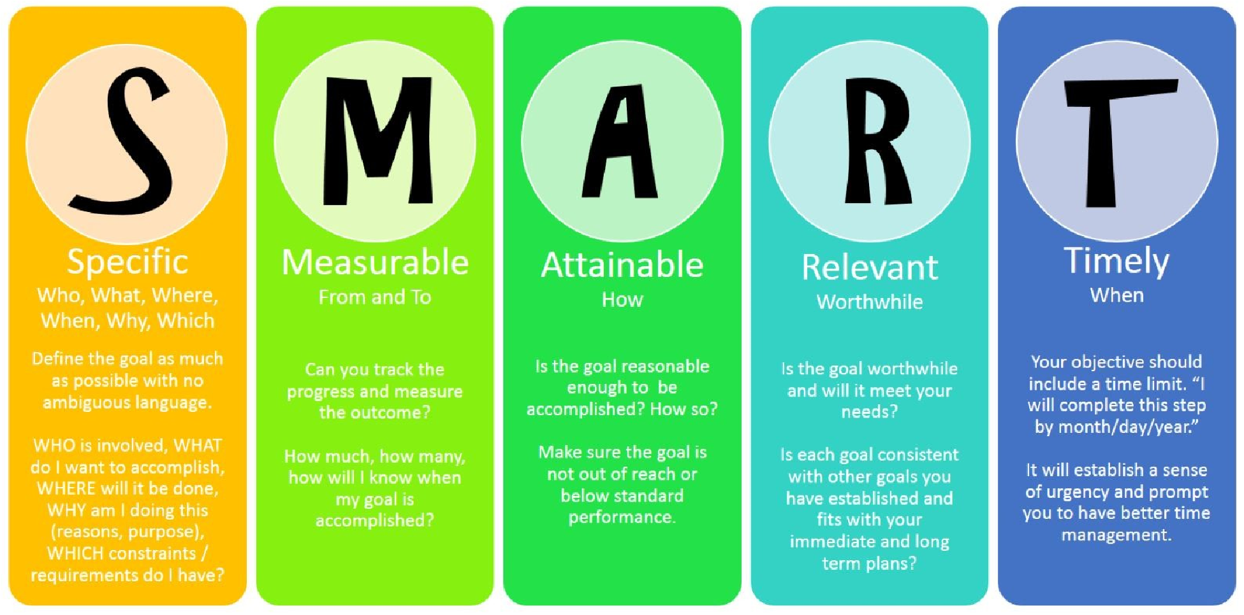

Figure 39 SMART Goals

# Conclusion

Professional Practice is a remarkably accurate barometer of a person’s career. It also has a profoundly positive effect upon the amorphous beast we call "Team morale". From this report the reader will gain a lot of information about professional development and problem-solving skills. In addition, the reader can gain a vast knowledge about teamwork and inter personal skills.

The author has vividly illustrated how to use the effective communication as well as how to work as a team in a given context. In this given context, the author has executed his skills and wellbeing’s in an effective manner as his team came victorious several times because of his work ethics. Surely, the author has gained a lot of experience through this training event because for him this was his first ever-organized training event. Even though he had prior experience in organization, he had never organized something like this. However, this was a huge elevation for his future career and hopefully he will use these experiences and work ethics in his future working career.

This report is a very important factor for an inexperienced reader who is willing to start his / her career. The working ethics, working methods, working tools and most importantly inter personal skills will have a lot effect on the readers’. However, the author has vividly described so many aspects of professional practice which any reader can gain some knowledge.

The readers can always have an image based and colorful idea about the above aspects where he or she can refer to the above figures and tables. Even by watching and understating those figures and pictures, readers can have a vivid idea about Professional Practice and Continuing Professional Practice.

# Reference

1. (c) Copyright skillsyouneed.com 2011-2018. 2018. *Problem Solving Skills | SkillsYouNeed*. [ONLINE] Available at: [https://www.skillsyouneed.com/ips/problemsolving.html.](https://www.skillsyouneed.com/ips/problem-solving.html) [Accessed 21 May 2018].
2. 5 Whys - Problem-Solving Skills From MindTools.com. 2018. *5 Whys - ProblemSolving Skills From MindTools.com*. [ONLINE] Available

at: [https://www.mindtools.com/pages/article/newTMC_5W.htm.](https://www.mindtools.com/pages/article/newTMC_5W.htm) [Accessed 24 May

2018].

1. Belbin.com. (2018). Belbin | Great teams start with Belbin. [online] Available at:

<http://www.belbin.com/about/belbin-team-roles/\>[Accessed 21 May 2018].

1. Brighthub Project Management. 2018. *Discover Critical Path Analysis Tools for Excel*. [ONLINE] Available at: [https://www.brighthubpm.com/project-planning/96367critical-path-analysis-tools-in-excel/.](https://www.brighthubpm.com/project-planning/96367-critical-path-analysis-tools-in-excel/) [Accessed 22 May 2018].
2. Campbell, S. (2018). 9 Tips Guaranteed to Build a Winning Team. [online] Entrepreneur. Available at: <https://www.entrepreneur.com/article/292425>

[Accessed 19 May 2018].

1. Continuing Professional Development. 2018. *The importance of continuing professional development (CPD)*. [ONLINE] Available at: [http://continuingprofessionaldevelopment.org/why-is-cpd-important/.](http://continuingprofessionaldevelopment.org/why-is-cpd-important/)

[Accessed 22 May 2018].

1. CPD - The CPD Certification Service. (2018). CPD Explained. [online] Available at:

<https://cpduk.co.uk/explained>[Accessed 21 May 2018].

1. Critical Thinking and Problem-solving. 2018. *Critical Thinking and Problem-solving*. [ONLINE] Available at: [https://www.utc.edu/walker-center-teachinglearning/teaching-resources/ct-ps.php.](https://www.utc.edu/walker-center-teaching-learning/teaching-resources/ct-ps.php) [Accessed 22 May 2018].
2. ERG motivation theory Alderfer | Employee motivation theories | YourCoach Gent.

2018. *ERG motivation theory Alderfer | Employee motivation theories | YourCoach Gent*. [ONLINE] Available at: [https://www.yourcoach.be/en/employee-motivationtheories/erg-motivation-theory-alderfer.php.](https://www.yourcoach.be/en/employee-motivation-theories/erg-motivation-theory-alderfer.php) [Accessed 25 May 2018].

1. Eventbrite UK Blog. (2018). 7 Steps to More Productive Meetings - Eventbrite UK Blog. [online] Available at: [https://www.eventbrite.co.uk/blog/more-productivemeetings-ds00/](https://www.eventbrite.co.uk/blog/more-productive-meetings-ds00/) [Accessed 20 May 2018].
2. Exam preparation for CBSE, CAT,GRE, GMAT, JEE, IAS. 2018. *Brainstroming | Definition And Meaning Of Brainstorming Techniques*. [ONLINE] Available at: [https://blog.byjus.com/techniques-for-brainstorming/.](https://blog.byjus.com/techniques-for-brainstorming/) [Accessed 21 May 2018].
3. Forming, Storming, Norming, and Performing - From MindTools.com.

2018. *Forming, Storming, Norming, and Performing - From MindTools.com*.

[ONLINE] Available at: [https://www.mindtools.com/pages/article/newLDR_86.htm.](https://www.mindtools.com/pages/article/newLDR_86.htm)

[Accessed 23 May 2018].

1. Gostrengths.com. (2018). What is Goal-Setting Theory? | GoStrengths!. [online] Available at: https://www.gostrengths.com/what-is-goal-setting-theory/ [Accessed

27 May 2018].

1. Harvard Business Review. (2018). What Everyone Needs to Know About Running Productive Meetings. [online] Available at: [https://hbr.org/2015/03/what-everyoneneeds-to-know-about-running-productive-meetings](https://hbr.org/2015/03/what-everyone-needs-to-know-about-running-productive-meetings) [Accessed 23 May 2018].
2. Herzbergs Two-Factor Theory of Motivation. 2018. *Herzbergs Two-Factor Theory of Motivation*. [ONLINE] Available at: [https://managementstudyguide.com/herzbergstheory-motivation.htm.](https://managementstudyguide.com/herzbergs-theory-motivation.htm) [Accessed 26 May 2018].
3. Houghton, W. and Maddocks, A. (2005) Engineering Subject Centre Guide: Personal

Development Planning for Engineering Students [Online], Loughborough, The Higher Education Academy Engineering Subject Centre. Available at <http://exchange.ac.uk/downloads/resources/pdp.pdf>[Accessed 17 May2018].

1. How to Create a Personal Development Plan | Mind of a Winner. 2018. *How to Create a Personal Development Plan | Mind of a Winner*. [ONLINE] Available at: [http://www.mindofwinner.com/create-personal-development-plan/.](http://www.mindofwinner.com/create-personal-development-plan/) [Accessed

25 May 2018].

1. Managementstudyguide.com. (2018). Performance Appraisal - Meaning, Objectives and Advantages. [online] Available at:

<https://www.managementstudyguide.com/performance-appraisal.htm>[Accessed

22 May 2018].

1. McClelland's Human Motivation Theory - From MindTools.com. 2018. *McClelland's Human Motivation Theory - From MindTools.com*. [ONLINE] Available at: [https://www.mindtools.com/pages/article/human-motivation-theory.htm.](https://www.mindtools.com/pages/article/human-motivation-theory.htm)

[Accessed 25 May 2018].

1. Me.udel.edu. (2018). [online] Available at:

<http://www.me.udel.edu/meeg304/08/teams-dynamics.pdf>[Accessed 20 May

2018].

1. Nazzaro, A. and Strazzabosco, J. (2018). GROUP DYNAMICS AND TEAM BUILDING.

2nd ed. [ebook] World Federation of Hemophilia (WFH), 2003; revised 2009. Available at: <http://www1.wfh.org/publication/files/pdf-1245.pdf>[Accessed 22 May

2018].